Francis Evariste Vicknair
December 3, 1914 – April 24, 1976

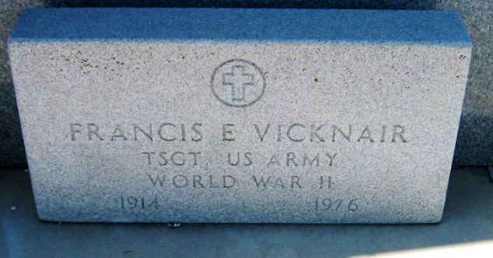
Photo by Bobby

Francis Everest Vicknair, on Saturday, April 24, 1976, at 9:30 o'clock a.m., beloved husband of Thelma Kliebert, father of Paul (Sharon) Luce, Mrs. Leon (Marguerite) Simolke, Linda, Cynthia, Patrick, Lynn and Roland Vicknair; brother of Mrs. Agnes King; also survived by 4 grandchildren, age 61 years, a native of Lions, La, and a resident of New Orleans, La.

Relatives and friends of the family, are invited to attend the funeral. A Requiem Mass will be celebrated in the Chapel of Jacob Schoen and Son, Inc, 3827 Canal St. at N. Scott, on Monday, April 26, 1976 at 12 o'clock noon. Interment in St Peter Cemetery, Reserve, La. A parishoner of Mater Dolorosa Catholic Church.
The Times-Picayune, New Orleans, Louisiana
April 25, 1976, p. 20

