Francis J. Vicknair
August 19, 1923 – December 20, 1975

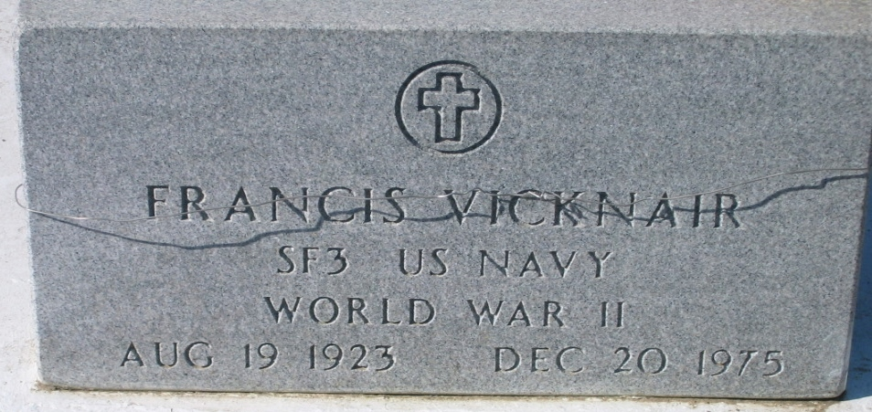
Photo by Bobby

Francis J. Vicknair, on Saturday, December 20, 1975 at 11:15 o'clock p.m.; beloved husband of Clara St Romain Vicknair; father of Mrs. Eugene (Mary Ann) Powell of New Sarpy, La, Mrs. Robert (Janet) Alexander, Todd J. Vicknair and Penny A. Vicknair, all of LaPlace, La, and the late Francis J. Vicknair; son of the late Mr. and Mrs. John W. Vicknair; brother of Mrs. Lloyd (Leona) Alleman of White Castle, La, and Anthony Vicknair of Reserve, La, and the late Etienne Vicknair; also survived by 4 grandchildren; age 52 years, a native and a resident of LaPlace, La.

Relatives and friends of the family are invited to attend the funeral. Services from the Alexander Funeral Home, 1499 West 5th Street, Laplace, La, on Tuesday, December 22, 1975 at 9:45 o'clock a.m. Religious services at St Joan of Arc Catholic Church. Interment in St Peter Cemetery, Reserve, La.
The Times-Picayune, New Orleans, Louisiana
December 22, 1975, p. 20

