Frank F. Vicknair III
August 9, 1936 – January 22, 2010

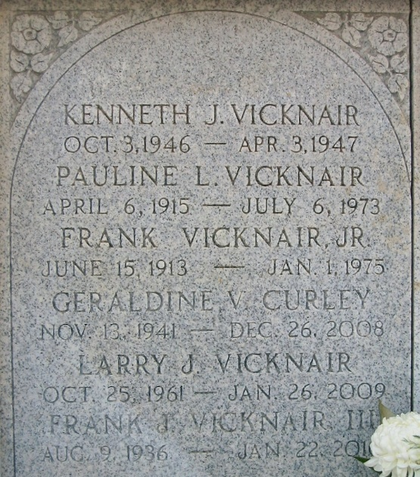
Photo by Bobby

Frank Vicknair, age 73, entered into eternal rest on Friday, January 22, 2010.
Relatives and friends of the family are invited to attend his Homegoing Celebration on Thursday January 28, 2010; Visitation will begin at 9:00am at the Betty Ann Sanders Memorial Chapel of Professional Funeral Service, Inc., 605 Main Street, Laplace, La. Interment will be private.
He was preceded in death by his son, Larry Vicknair; 1 sister Geraldine Curley.
He leaves to cherish his precious memories, his wife, Hilda Vicknair; 2 sons, John and Chris Vicknair, 1 daughter, Becky O'Rillion; 1 granddaughter, Rhea Triche; 1 sister Gladys Elfer; 3 brothers, Gary, Gerald, and Floyd Vicknair, and other relatives and friends.
Services entrusted to the caring staff of: Professional Funeral Service, Inc., Laplace, Louisiana 70068 (985) 652-1730

The Times-Picayune, New Orleans, Louisiana
Jan. 27, 2010

