Frank Vicknair Jr.
June 15, 1913 – January 1, 1975

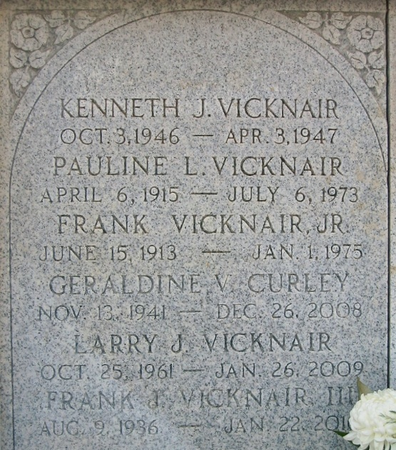
Photo by Bobby

Frank Vicknair Jr, on Wednesday, January 1, 1975 at 1:30 o'clock a.m.; husband of the late Pauline LaBranche; father of Frank III, Floyd, Gerald, Geraldine and Gary of LaPlace, La, Mrs. Lyle (Gladys) Elfer, of Reserve, La; brother of Jordan and Godfrey Vicknair, Mrs. Mabel Madere, Mrs. Lucy Guillory, and the late Odette Guillory and Simone Clement; also survived by 14 grandchildren; age 61 years, a native and resident of LaPlace, La.

Relatives and friends of the family, are invited to attend the funeral. Services from the Millet Funeral Home, LaPlace, La, on Friday, January 3, 1975 at 10 o'clock a.m. followed by religious services at St Joan of Arc Catholic Church, LaPlace, La. Interment in St Peter Cemerery, Reserve, La.
The Times-Picayune, New Orleans, Louisiana
January 2, 1975, p. 12

