Gene Joseph Vicknair
July 6, 1946 – August 29, 2008

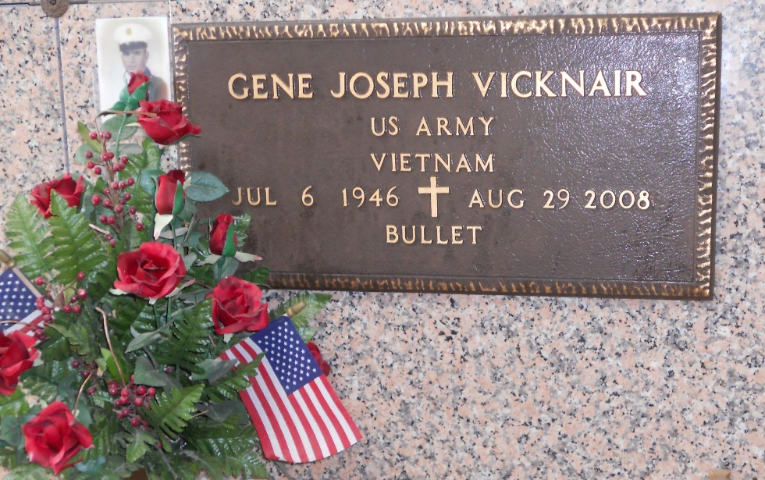
Photo by Team T-Lo

Gene Joseph "Bullet" Vicknair passed away on Friday, August 29, 2008, at 62 years of age.
Beloved husband of Marlene Babin Vicknair. Father of Troy A. Vicknair and wife Renee and Tanya V. Andrepont and husband Alan. Paw Paw of Brook and Brandon Vicknair and Jason and Blair Andrepont. Son of Ernest and Congetta Vicknair, deceased.
Employee of Shell Oil Norco for 34 years. Raised in Norco and resident of Laplace for the past 34 years. Gene was the first Veteran to enter the Southeast Louisiana War Veterans Home, Reserve, on June 11, 2007.
Donations are accepted at the Alzeimer's Association, Greater New Orleans region. 2605 River Road, New Orleans La, 70121.

The Times-Picayune, New Orleans, Louisiana
Sep. 17, 2008

