Glenda (Louque) Vicknair
November 12, 1938 – October 10, 2000

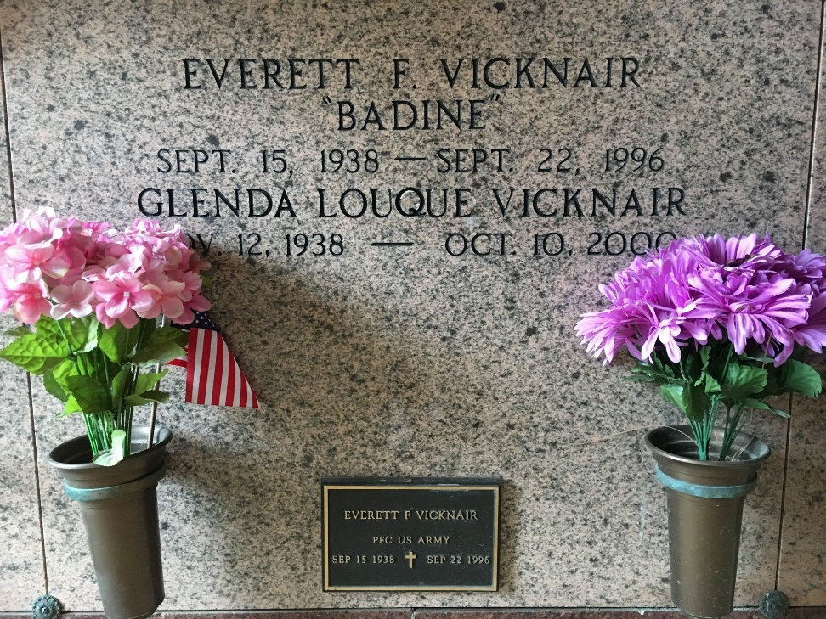
Photo by Team T-Lo

Glenda Louque Vicknair, 61, a native of Paulina and resident of Reserve for 35 years, died Oct. 10. She was the wife of the late Everett "Badine" Vicknair and mother of Kenneth and Keith Vicknair. She was also the daughter of the late Logan and Ina Marie Roper Louque and sister of Warren, Logan and Richard Louque.

Services were Oct. 13 at St. Peter Catholic Church, Reserve, with interment at the church cemetery.
L'Observateur, LaPlace, Louisiana
October 14, 2000

