Gustave Vicknair
May 12, 1895 – September 30, 1952

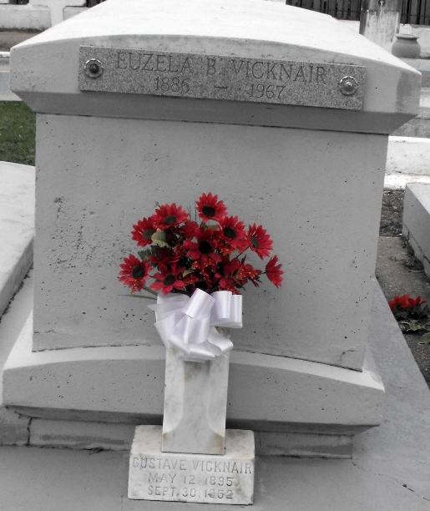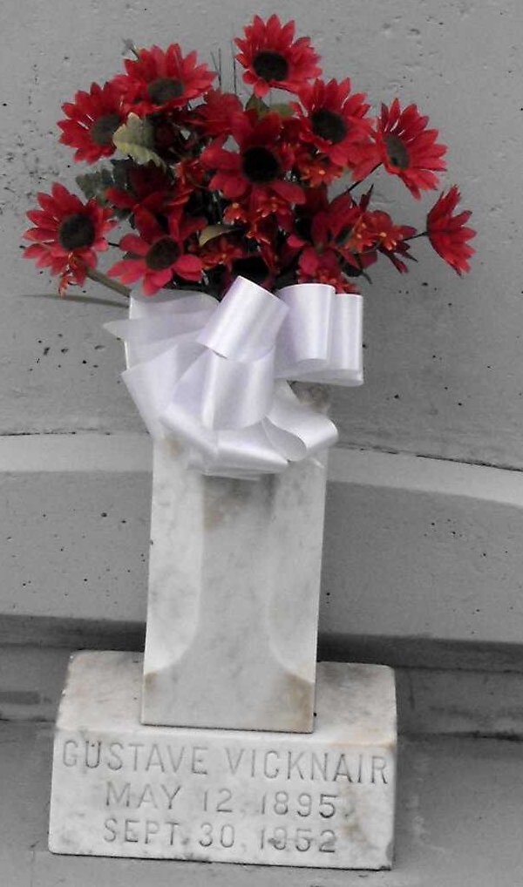
Photo by Mary Agnes Hammett

VICKNAIR - At his residence, Reserve, La, on Tuesday, September 30, 1952, at 2 o'clock a.m., GUSTAVE (UNE) VICKNAIR, son of the late Marie Brady and Gustave Vicknair, half brother of Euseia Boudousquie Vicknair and Zepherin Vicknair and the late Elise Jacob, Ametius and Edward Vicknair; age 57 years, 4 months, 25 days.

Relatives and friends of the family, also members of St Peter's Usher Society and St Peter's Holy Name Society are invited to attend the funeral, which will take place from the Millet Funeral Home, Reserve, La, on Wednesday, October 1, 1952, at 9:20 o'clock a.m., followed by mass at St Peter's church, Reserve, La. Interment in St Peter's cemetery, Reserve, La.
The Times-Picayune, New Orleans, Louisiana
October 1, 1952, p. 2

