Guy Alphonse Vicknair Jr.
May 13, 1950 – December 31, 1973

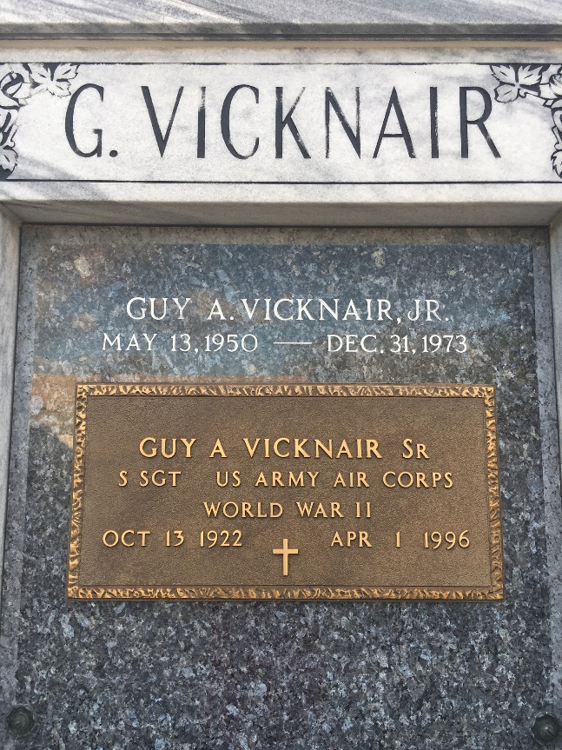
Photo by Team T-Lo

Guy Alphonse Vicknair Jr, of Montz, La, on Monday, December 31, 1973, at 8:30 o'clock a.m., beloved son of Guy A. Vicknair Sr, and Julie Madere Vicknair, of Montz, La, brother of Mrs. Jan (Donna) Compton, of LaPlace, La; age 23 years; a native of New Orleans, La, and a resident of Montz, La.

Relatives and friends of the family, also employes of Shell Oil Co, of Norco, La, and General American Tank Corporation of Good Hope, La, are invited to attend the funeral. Services from Millet Funeral Home, LaPlace, La, on Thursday, January 3, 1974 at 10 o'clock a.m. followed by religious services at St Joan of Arc Catholic Church, LaPlace, La. Interment in St Peter Cemetery, Reserve, La.
The Times-Picayune, New Orleans, Louisiana
January 2, 1974, p. 16

