Harold A. Vicknair Sr.
March 26, 1926 – January 26, 2011

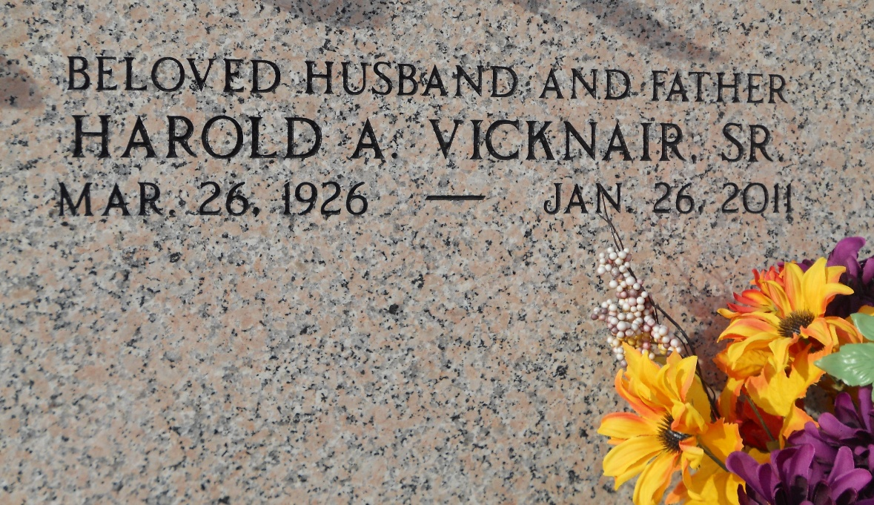
Photo by Team T-Lo

Harold A. Vicknair passed away on Wednesday, January 26, 2011. Beloved husband of the late Dorothy Scioneaux Vicknair. Father of Donna Rose, Laura Petit, Maria Mills, Harold A. Vicknair Jr. and the late Cindy Zeringue. Also survived by 9 grandchildren and 7 great-grandchildren. Brother of Dan Vicknair and the late Timothy and Chateno Vicknair. Age 84. A native of LaPlace, La. and a resident of Luling, La.

Relatives and friends are invited to attend services. Visitation at Millet-Guidry Funeral Home, 2806 W. Airline Hwy., LaPlace, La., on Friday, January 28, 2011 from 11:00 am to 12:45 pm, followed by Mass at St. Peter Catholic Church, Reserve at 1:00 pm. Burial in church cemetery.
The Times-Picayune, New Orleans, Louisiana
January 27-28, 2011

