Harold J. Vicknair
April 11, 1926 – March 21, 2007

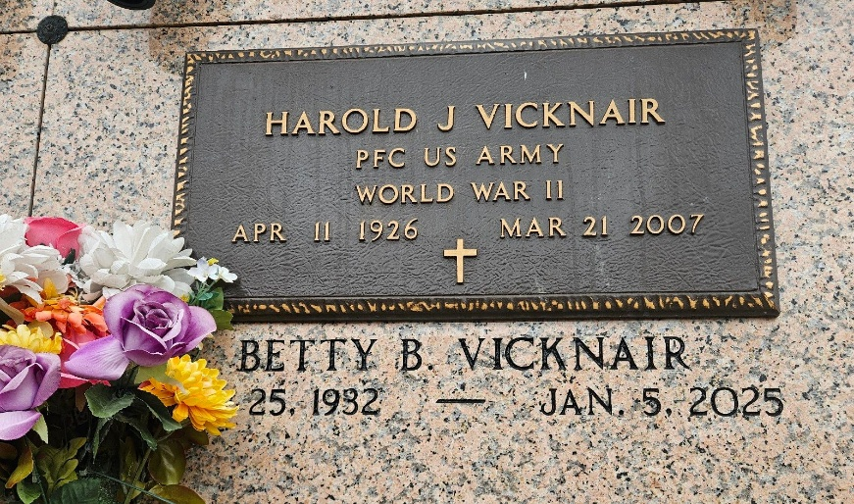
Photo by Team T-Lo

Harold J. Vicknair died on Wednesday, March 21, 2007, at 11:23 a.m. He was the beloved husband of Betty Brown Vicknair for 58 1/2 years, father and father-in-law of Bryan and Phoebe Forman Vicknair of Maurepas, Randy and Debbie Audiffred Vicknair of Reserve, Karla Vicknair and Ricky Dencausse of St. Amant, and Dina Vicknair Gremillion of Garyville. He is also survived by his cat, Buddy. He was the grandfather of Dawn V. Boyle, Theresa V. Hays, Jennie V. Catoire, Randi Lyn V. Behrans, Rick, Kourtney and Kaleb Dencausse and Michael Gremillion, great-grandfather of Ashlee, Ryan and Benji Hayes, Nicole, Shaina and Reagan Catoire, Josha Boyle and Remie Behrans, son of the late Emile and Clothilde Millet Vicknair, brother of E. J. and wife Ruth Vicknair, Lois Caillouet and the late Dorothy Ory, and nephew of Mildred Brignac. He is also survived by many nieces, nephews, cousins and friends.
He was a U.S. Army veteran of World War II, having served in Europe. A local musician, he played the saxophone with many local bands for 60 years and for local nursing homes, receiving much pleasure from seeing the residents enjoy themselves. He was 80 and a native and resident of Garyville.
Relatives and friends of the family are invited to attend services. Visitation at Millet-Guidry Funeral Home, 2806 W. Airline Highway, LaPlace, on Thursday, March 22, from 5 p.m. to 9 p.m. Visitation at St. Hubert Catholic Church, Garyville, on Friday from 9 a.m. until religious service at 10:30 a.m. Burial in St. Peter Cemetery, Reserve.
TheAdvocate.com
March 22, 2007

