Henry ‘Bool’ Vicknair
May 26, 1907 – May 30, 1974

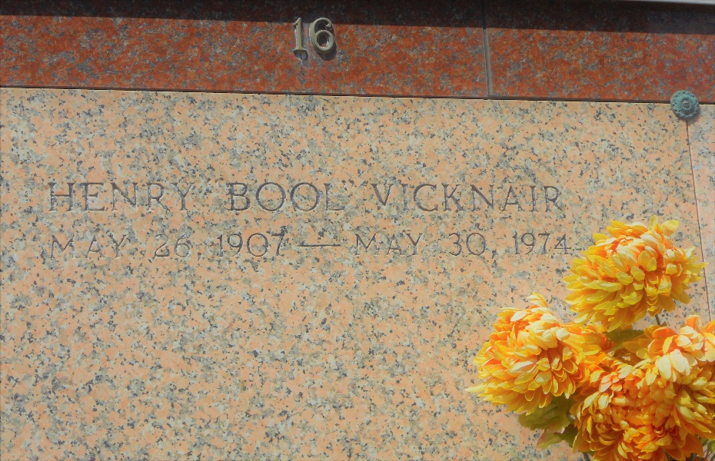
Photo by Team T-Lo

Henry (Bool) Vicknair, on Thursday, May 30, 1974 at 10:05 o'clock a.m., beloved husband of Louise Granier Vicknair; father of James S. and Gail Vicknair of Reserve, La, and Mrs. Allen (Gloria) Loupe, of Galliano, La; brother of Charles, Benoit, and Jack Vicknair, Mrs. George Bertrand, all of Reserve, La, Mrs. Rene Bienvenue of LaPlace, La, Mrs. Carman Madere of New Orleans, La, and the late Nick Vicknair; also survived by 9 grandchildren; age 67 years; a native and a resident of Reserve, La.

Relatives and friends of the family, also employees of Godchaux-Henderson Sugar Refinery and Louisiana Highway Dept, are invited to attend the funeral services from Millet Funeral Home, Reserve, La, on Saturday, June 1, 1974 at 10 o'clock a.m. followed by religious services from St Peter Catholic Church, Reserve, La. Interment in St Peter Cemetery, Reserve, La.
The Times-Picayune, New Orleans, Louisiana
May 31, 1974, p. 18

