Henry Urbain Vicknair
September 8, 1894 – August 19, 1918

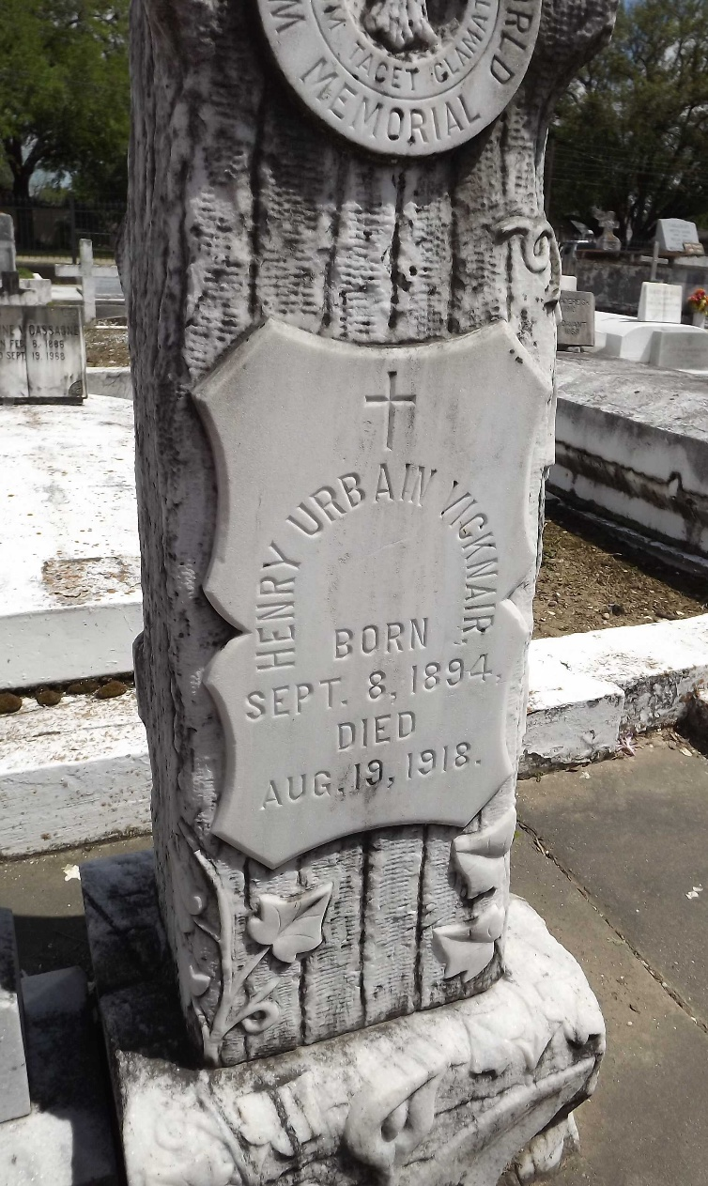
Photo by Mary Agnes Hammett

VICKNAIR - On Monday, Aug. 19, 1918, at 4 o'clock p.m., URBAIN VICKNAIR, beloved son of Eugenia Gros and Henry Vicknair, aged 22 years, 11 months, a native of Reserve, La, and a resident of Marrero, La. Remains will be shipped this afternoon, Aug. 20, 1918, to Reserve, La, for interment.
The New Orleans States, Louisiana
20 Aug 1918, p. 6

