Hollie Gay (Henderson) Vicknair
July 2, 1944 – December 11, 2007

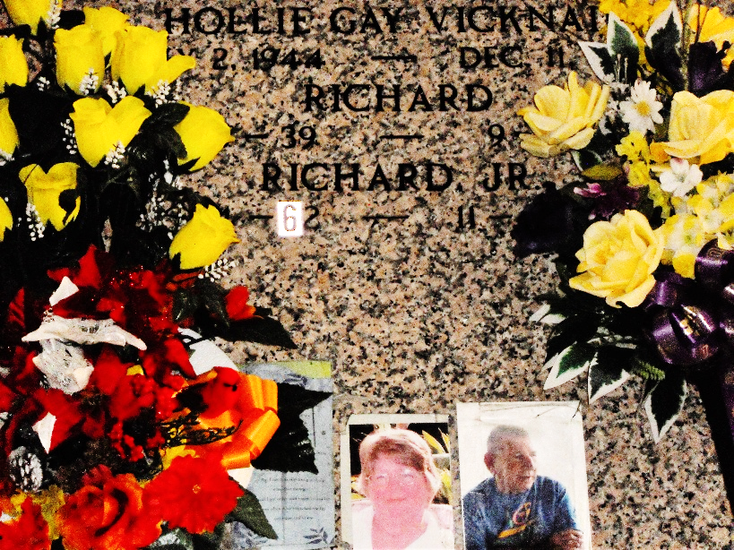
Photo by Team T-Lo

A retired accountant with the Louisiana Department of Transportation, she was entrusted to God's loving care Tuesday, Dec. 11, 2007, at her home in Reserve. She was 63 and a native of Provo, Utah.
Visitation will commence at Ourso Funeral Home, Donaldsonville, on Friday, Dec. 14, from 9 a.m. until chapel service at 11 a.m., conducted by the Rev. Edward R. Robertson. A private burial will follow at a later date.
She is survived by her husband, Richard Vicknair, Reserve; two daughters, Hollie Ramagos and Katheryn LeBlanc; five stepdaughters, Belinda Bourgeois, Crystal Vicknair, Susette Strange, Lillian Vicknair and Laurie Franklin; two sons, David Ramagos and Thomas Ramagos; two stepsons, Richard Vicknair Jr. and Johnny Vicknair; three sisters, Tommily King, Neena Nelson and Micki Wiley; 14 precious grandchildren and her pet baby, Skip.
She was preceded in death by her parents, Holl and Bernice Brierly Henderson; first husband, Earl Noe Ramagos; two grandchildren, Lee Daniel Richard III and Dillion Simms; and a son-in-law, James Comeaux.
The Advocate, Baton Rouge, Louisiana
Dec. 13, 2007

