Irene (Perque) Vicknair
February 4, 1916 – May 31, 2009

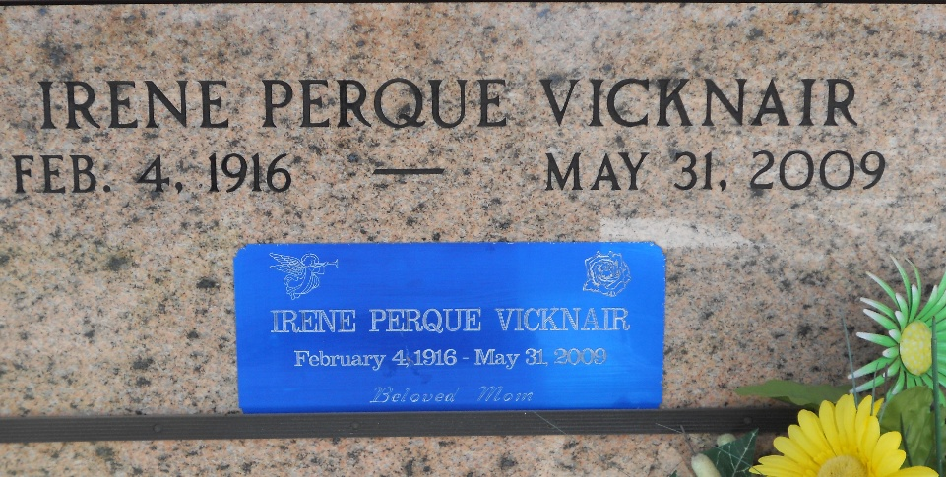
Photo by Team T-Lo

Irene Perque Vicknair on Sunday, May 31, 2009 at 8:20 am. Beloved wife of the late Adrian (LeLare) Vicknair Sr. Mother of Calvin, Lester & Adrian Vicknair Jr., Elsie Gueret, Celine Bardwell, Elaine Tregre, Janice Stein and Verta Root. Also survived by 19 grandchildren, 23 great-grandchildren and 29 great-great-grandchildren. Sister of Abdon Perque. Age 93. A native of Chackbay, La. and a resident of Reserve, La.

Relatives and friends are invited to attend services. Visitation at Millet-Guidry Funeral Home, 2806 W. Airline Hwy., LaPlace, La., on Wednesday, June 3, 2009 from 10:00 am to 12:00pm. Followed by Religious Services in the Funeral Home Chapel at 12 noon. Burial in St. Peter Cemetery, Reserve, La.
The Times-Picayune, New Orleans, Louisiana
June 2, 2009

