James Albert Vicknair
March 26, 1934 – March 11, 2025

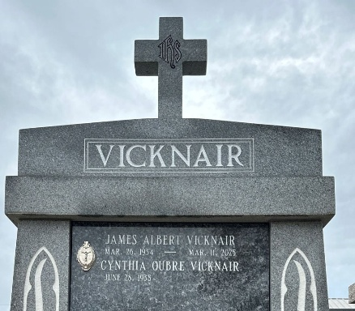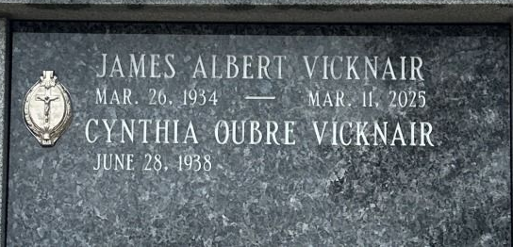
Photo by Team T-Lo

James Albert Vicknair (Jim) was called by God to his eternal home on March 11, 2025.
Jim was born on March 26, 1934, a life-long resident of Reserve, LA. He was the son of the late Felicien and Ceria (Clement) Vicknair. He is preceded in death by his brother John and sister Rita Vicknair Bell.
Jim served in the U.S. Navy and worked for 40 years at Shell Oil Company in Norco, LA. He worked in various areas of the plant. He was very skilled with his hands and could fix almost anything. He was loving, dependable, honest and trustworthy. One activity that Jim always enjoyed was to dance. His feet would tap and hands would clap to music even up to his final days.
Jim met the love of his life, Cynthia Oubre Vicknair, in high school. They were married for 67 years and raised a family of six children - Brian (Teri), Darren (Jill), Mark (Yvonne), Loretta Duguid (George), Glenn (Vicki), and Tricia Jacob (Ken). He is survived by ten grandchildren and two great grandchildren. He also leaves behind many loving nieces, nephews and cousins.
For Jim, his faith and family meant the world to him. He worked on various projects and activities for the church. He also loved having his family around and was a very devoted husband, father and friend.
The family would like to express their heartfelt thanks and appreciation to his caregivers Kushmala Murphy, Cheryl Rose, Donna Funderburk, Gloria Anderson and other caregivers who supported our journey. We would also like to thank Notre Dame Hospice Staff for their loving care.
Family and friends are warmly invited to gather on March 17, 2025 at St. Joan of Arc Catholic Church in Laplace, LA, to honor and celebrate a life well lived. The Rosary will be said at 9:40 a.m. with visitation for all to follow at the church from 10:00 a.m. to 12:00 p.m. A Mass of Christian Burial immediately following at 12:00 p.m. Interment will follow at St. Peter Catholic Church Cemetery, where final respects will be made.
In lieu of flowers, mass donations can be made to St. Peter Catholic Church or the Alzheimer's Association (Alz.org).

Millet-Guidry Funeral Home, LaPlace, Louisiana

