James A. Vicknair Sr.
September 14, 1927 – December 18, 2014

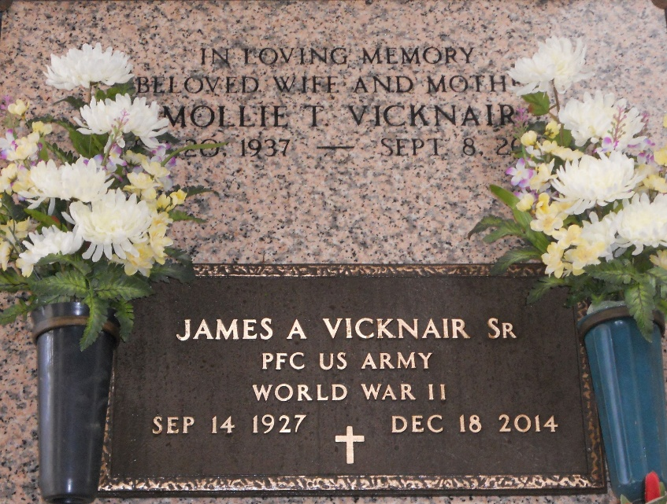
Photo by Team T-Lo

James A. 'Tim' Vicknair, Sr. passed away on Thursday, December 18, 2014 at the age of 87. He was a resident of LaPlace.
Beloved husband of the late Mollie Hebert Vicknair. Father of Catherine Cazes, Nancy Kidwell, Katy Duhe and Daniel, James Jr., Steven and Karl Vicknair. Son of the late Clothilde Madere Vicknair and Edward Vicknair. Brother of Sidney 'Polly' Vicknair and the late George Vicknair and Harold Vicknair. Also survived by 17 grandchildren, 34 great-grandchildren and many nieces and nephews.
Relatives and friends are invited to attend the Funeral Mass at St. Joan of Arc Catholic Church, 529 W. 5th St., LaPlace on Tuesday, December 23, 2014 at 12:00 p.m. Visitation will begin in church at 9:30 a.m. Interment in St. Peter Cemetery. Arrangements by Millet-Guidry Funeral Home.

The New Orleans Advocate, Louisiana
Dec. 20 to Dec. 23, 2014

