Jean Vicknair
July 8, 1858 – March 23, 1922

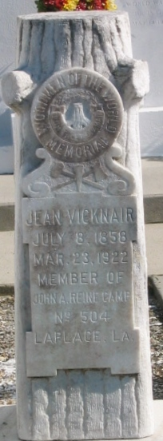
Photo by Bobby

Jean Vicknair died at his home in Laplace, LA, Thursday night at age 63. He was a lifelong resident of Ward 4 of the parish. Funeral services were Friday at St Peter Church with interment in St John the Baptist Cemetery, Edgard (sic), LA.

L'Observateur, LaPlace, Louisiana
25 Mar 1922, p. 1

