John Joseph Vicknair Sr.
March 20, 1923 – October 2, 2007

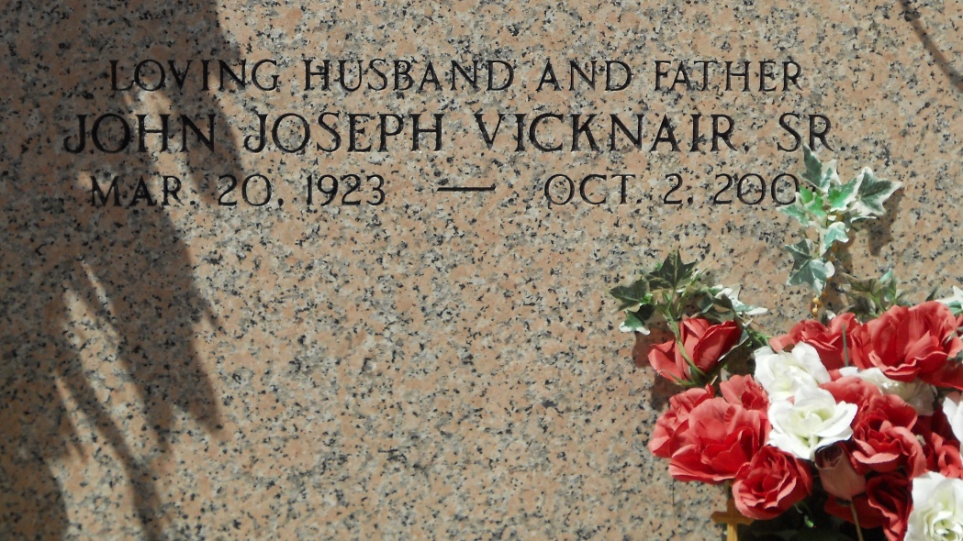
Photo by Team T-Lo

John J. Vicknair, Sr. on Tuesday, October 2, 2007 at 2:25 p.m. Beloved husband of the late Anna Rose Duhe Vicknair. Father of John Jr., Robert, Terry and Donald Vicknair, Laura Amedee, Katheleen Allen and Mary Loup.
Son of the late Felicien and Ceria Vicknair. Brother of James Vicknair and Rita Bell. Also survived by 23 grandchildren and 20 great grandchildren. He enjoyed playing music for the Senior Citizens. Age 84 years. A native and resident of Reserve, LA.
Relatives and friends are invited to attend services. Visitation at St. Peter Catholic Church, Reserve, La. on Friday, October 5, 2007 from 9am to 11am. Followed by Religious Services at St. Peter Church at 11am. Burial in St. Peter Cemetery Reserve, La. Arrangements by Millet-Guidry Funeral Home, LaPlace, La.
The Times-Picayune, New Orleans, Louisiana
October 4, 2007

