John Louis Vicknair
June 6, 1890 – August 20, 1952

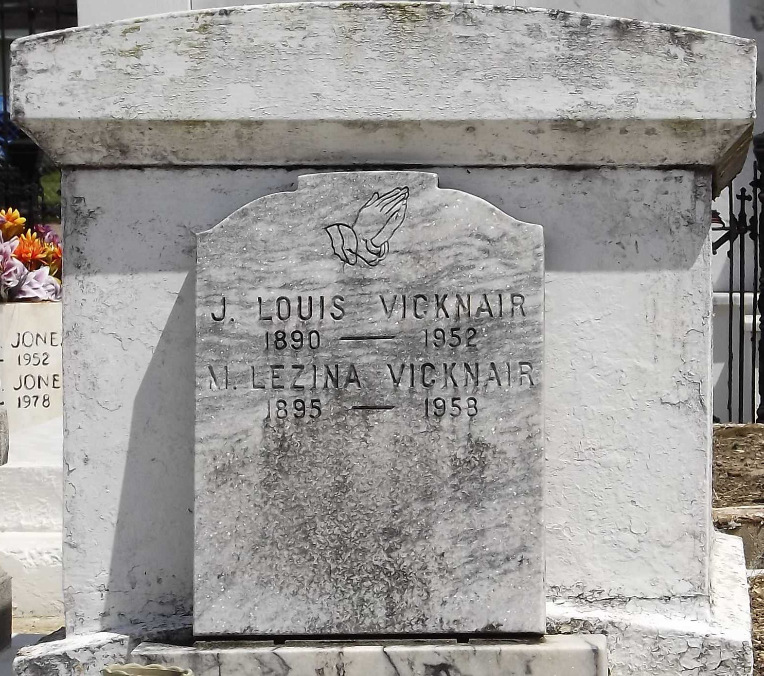
Photo by Mary Agnes Hammett

On Wednesday, August 20, 1952, at 9:20 o'clock p.m., JOHN LOUIS VICKNAIR, beloved husband of Marie Lezinia Keller, father of Mrs. Carol de Boutte, Mrs. Lezinia Guidry, Mrs. Rosemary Madere, Mrs. Alice Mae Schultz, Mrs. Carmen Wilson, Mrs. Lois Sausier, and J. J. Jr, and Gean Marius Vicknair, also survived by 14 grandchildren, age 62 years.

Relatives and friends of the family are invited to attend the funeral, which will take place from Millet Funeral Home, Reserve, La, on Friday, August 22, 1952, at 2 o'clock p.m. Religious services at St Peter's Church, Reserve, La. Interment in St Peter's cemetery, Reserve, La..
The Times-Picayune, New Orleans, Louisiana
August 22, 1952, p. 2

