Leatrice (Cavalier) Vicknair
June 13, 1931 – August 31, 2011

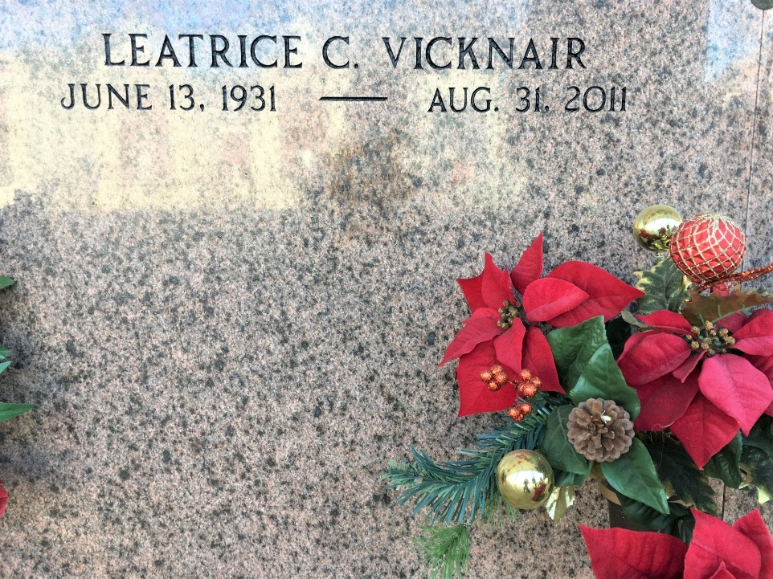
Photo by Team T-Lo

Leatrice Cavalier Vicknair passed away on Wednesday, August 31, 2011. Beloved wife of Earl (BooBoo) Vicknair. Mother of Melanie Vicknair, Kristen Preucil and Sonya Lulich. Grandmother of Britt Kennedy Jr., Dustin Kennedy, John Lulich III and Jayne Preucil. Also survived by 5 great grandchildren.

Daughter of the late Edward and Lilly Cavalier. Sister of Marion Fremin, Joyce Clement and the late Curtis, Shirley and Wilbert Cavalier. Age 80 years. A native and resident of Reserve.

Relatives and friends are invited to attend service. Visitation at St. Peter Catholic Church, Reserve on Saturday, September 3, 2011 from 8:00AM until 10:00AM. Followed by a Mass at 10:00AM. Burial in St. Peter Cemetery, Reserve, LA. Arrangements by Millet-Guidry Funeral Home, LaPlace.

The Times-Picayune, New Orleans, Louisiana
September 1, 2011

