Letitia (Delauneville) Vicknair
April 7, 1893 – July 25, 1972

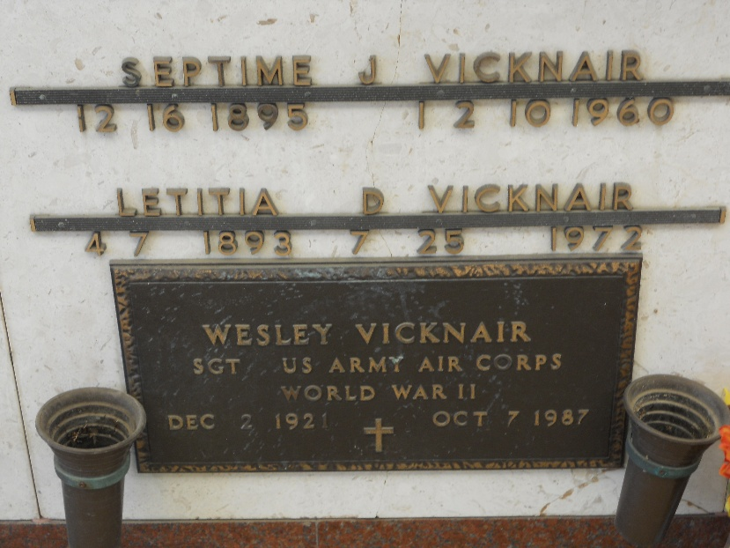
Photo by Team T-Lo

Letitia Delauneville Vicknair, on Tuesday, July 25, 1972, at 3:15 o'clock p.m.; wife of the late Septine Vicknair; mother of Wesley Vicknair of Kenner, La; sister of Horace and Joseph Delauneville, Mrs. Maurice Granier and Mrs. Sidney Savoie, all of Reserve, La, also survived by two grandchildren and two great grandchildren; age 79 years; a native and a resident of Reserve, La.

Relatives and friends of the family, also members of VFW Post 3267, Harahan, La, and Pontchartrain Levee Board, are invited to attend the funeral. Services from Millet Funeral Home, Reserve, la, on Thursday, July 27, 1972, at 9:15 o'clock a.m., followed by religious services at St Peter's Catholic Church, Reserve, La. Interment in St Peter's Cemetery, Reserve, La.

The Times-Picayune, New Orleans, Louisiana
July 26, 1972, p. 14

