Lionel C. Vicknair
March 7, 1897 – July 2, 1984

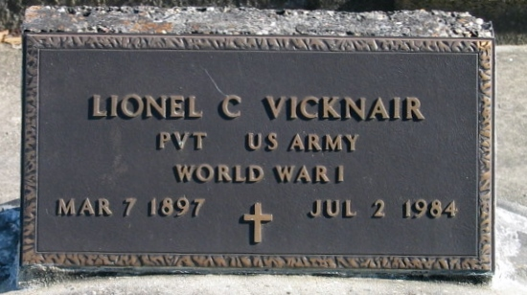
Photo by Bobby

Lionel C. (Nell) Vicknair, on Monday, July 2, 1984 at 5:45 p.m.

Beloved son of the late Clement Vicknair and Fidelise Montz Vicknair. Survived by a host of cousins. Age 87 years. A native and life long resident of Reserve, La.

Relatives and friends of the family are invited to attend the Services from Millet Funeral Home, Reserve, La, on Thursday, July 5, 1984 at 10 o'clock a.m. followed by Religious Services at St Peter Catholic Church. Interment in church cemetery, Reserve, La.

The Times-Picayune, New Orleans, Louisiana
July 4, 1984, p. 38

