Luke E. Vicknair
July 27, 1887 – December 16, 1948

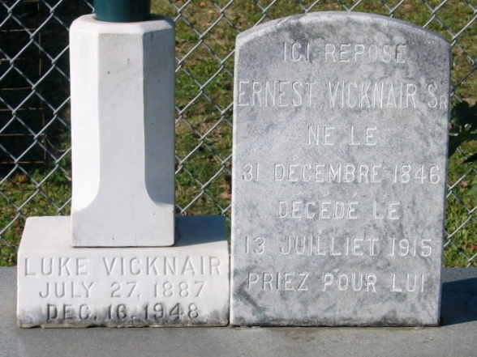
Photos by Bobby

VICKNAIR-At the Baptist hospital on Thursday, December 16, 1948, at 11:20 o'clock a.m., LUKE E. VICKNAIR, brother of Mrs. Louise Ory and a host of nieces and nephews; aged 61 years; a native of St Charles parish, Louisiana, and a resident of Mount Airy for years.

Relatives and friends of the family, also officers and members of Knights of Columbus of the Gramercy Council 1817, are invited to attend the funeral, which will take place from Alexander Funeral Home, Lutcher, La, on Friday, December 17, 1948, at 3:30 o'clock p.m., followed by religious services at St Hubert's church, Garyville, La, at 4 p.m. Interment in St Peter's cemetery, Reserve, La.

The Times-Picayune, New Orleans, Louisiana
December 17, 1948, p. 2

