Lutha (Berthelot) Vicknair
June 19, 1900 – January 20, 1973

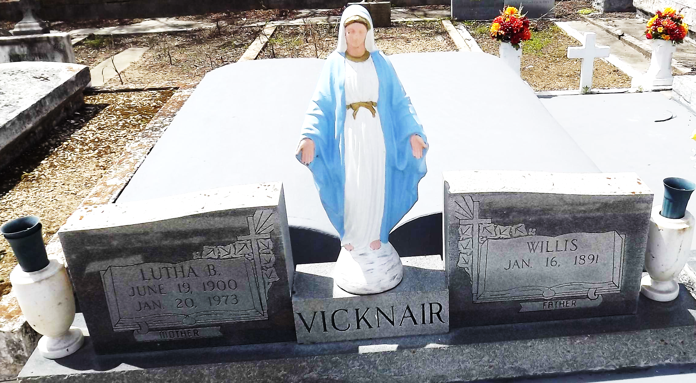
Photo by Mary Agnes Hammett

Lutha Berthelot Vicknair of Reserve, La, on Saturday, January 20, 1973, at 10:00 o'clock a.m.; beloved wife of Willis Vicknair; mother of Mrs. Marvin (Sybil) Beaver of Thibodaux, La, Mrs. Hilda Peranio of Montz, La, and the late Percy E. Vicknair; sister of Nolan Berthelot of Gonzales, La, Mrs. A. J. Mayers of Baton Rouge, La, Mrs. Claude St Amant of Metairie, La, and the late Mrs. Peter Richard, Mrs. Frank Audiffred, Mrs. Frank Battard, all of Reserve, La, and Wilfred Berthelot of Baton Rouge; also survived by seven grandchildren and six great grandchildren; age 72 years; a native of St Gabriel, La, and a resident of Reserve, La.

Relatives and friends of the family are invited to attend the funeral. Services from Millet Funeral Home, Reserve, La, on Monday, January 22, 1973, at 11:15 o'clock a.m., followed by religious services at St Peter Catholic Church, Reserve, La. Interment in Church cemetery.

The Times-Picayune, New Orleans, Louisiana
January 21, 1973, p. 18

