Marie Lelia (Hymel) Vicknair
August 15, 1896 – May 5, 1954

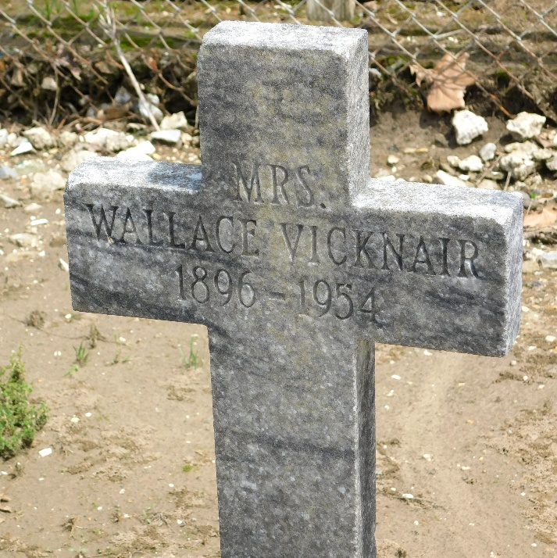
Photo by Mary Agnes Hammett

VICKNAIR – In Garyville, La., on Wednesday, May 5, 1954, at 9:10 o’clock p.m. Lylia Hymel, beloved wife of Wallace Vicknair Sr., mother of Mrs. Odile Duhon, Percy P., Earl, Wallace Jr. and Etta Mae Vicknair, also survived by nine grandchildren, aged 57 years.

Relatives and friends of the family are invited to attend the funeral which will take place from Millet Funeral Home, Reserve, La., on Friday, May 7, 1954, at 8:30 o’clock a.m. Religious services at St. Hubert’s church, Garyville, La., at 9 o’clock. Interment in St. Peter’s cemetery, Reserve, La.

The Times-Picayune, New Orleans, Louisiana
Friday May 7, 1954, p. 2

