Marie Victoria (Englade) Vicknair
July 20, 1881 – September 24, 1958

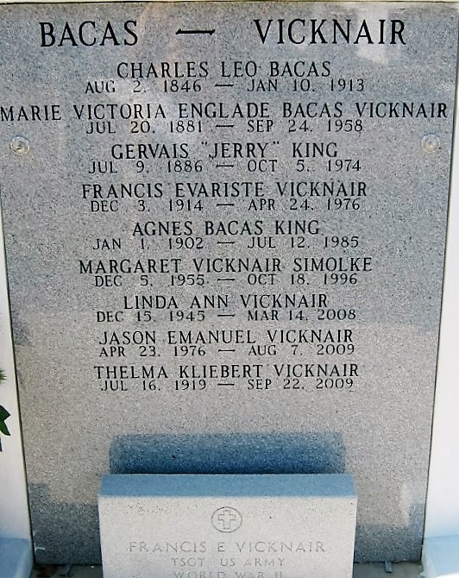
Photo by Bobby

Victoria Englade, age 77 years, 2 months, died at her daughter, Mrs. Gervais King, in Jefferson Parish, Louisiana, on Wednesday, 24 Sep 1958.
She was the wife by first marriage of Ferdinand Bacas and by second marriage of Louis O. Vicknair.
She was the mother of Mrs. Gervais King of Jefferson Parish, and Francis E. Vicknair of New Orleans. She was the sister of Mrs. Louise Montz of Lions, Louisiana, and Georgia Englade of New Orleans.
She was a native of Lions and a resident of Garyville, Louisiana, for 40 years and a late resident of Jefferson Parish for the past 3 years.
Services were Thursday, 25 Sep 1958 at St. Peter Church, Reserve, Louisiana, with interment in St. Peter Cemetery.

Unknown source

