Malcolm J. Vicknair
June 22, 1933 – November 28, 1955

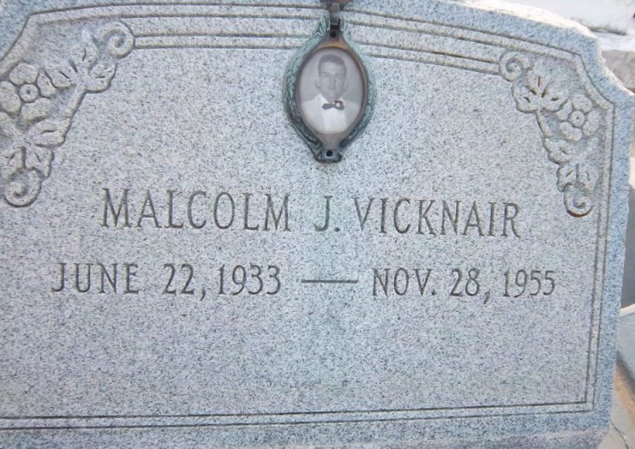
Photo by Dwayne Montz

VICKNAIR-On Monday, November 28, 1955, at 2 o'clock p.m., MALCOLM VICKNAIR, son of Edward Vicknair Jr. and Lillian Le Blanc; brother of Mrs. Mildred Oubre, Misses Anna Lee and Sylvia Vicknair, O. J. and Richard Vicknair; grandson of Mrs. Edward Vicknair Sr, aged 22 years.

Relatives and friends of the family are invited to attend the funeral which will take place from the Millet Funeral Home, Reserve, La, on Tuesday, November 29, 1955, at 4 o'clock p.m., followed by religious services at St Peter's Church, Reserve, La. Interment in St Peter Cemetery.

The Times-Picayune, New Orleans, Louisiana
November 29, 1955, p. 2

