Marcellin Vicknair Jr.
July 10, 1877 – June 27, 1950

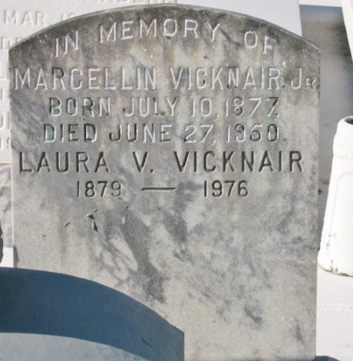
Photo by Bobby

Died at Laplace, Louisiana, at age 73 years, 11 months and 13 days. Husband of Laura Vicknair, father of Mrs. Paul Giangrosso, Mrs. Lucille Chassaniol of New Orleans, and Walter Vicknair of Laplace.

Brother of Mrs. Oscar Bossier, Maud and Louis Vicknair and the late George Vicknair. Son of Marcelin Vicknair Sr. and Elsie Daron.

Services were Wednesday, 28 Jun 1950, at St Peter Church, Reserve, Louisiana, with interment in St Peter Cemetery.

The Times-Picayune, New Orleans, Louisiana
June 28, 1950

