Marie Lezina (Keller) Vicknair
February 22, 1895 – June 24, 1958

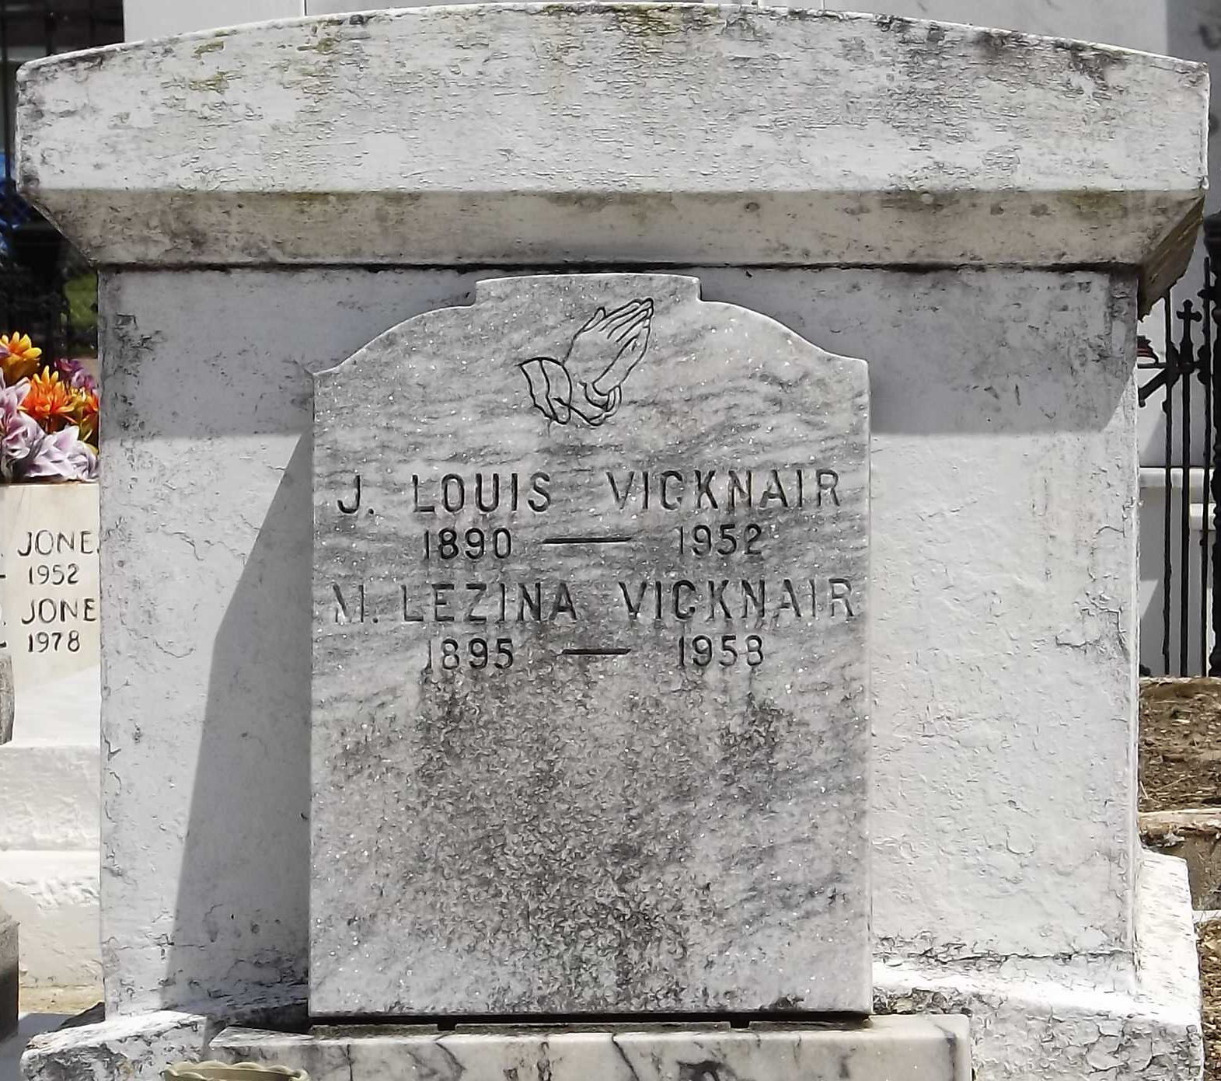
Photo by Mary Agnes Hammett

On Tuesday, June 24, 1958, at 11:30 o'clock a.m., MARIE LEZINA, wife of the late John Louis Vicknair; mother of Mrs. Delton Debautte, Mrs. Irvin Madere, Mrs. Mark Klibert and John L. Vicknair of Reserve, La, Mrs. Ernest Guidry, Mrs. Howard Shultz, Mrs. Francis Saucier and Jean M. Vicknair of New Orleans, La; sister of Sister Mary Yolande, Mrs. John Dresel, Mrs. Willie Braud, Mrs. Martha Keller, George and Leon Keller; age 63 years, 4 months, 2 days; a native of St John the Baptist Parish and a resident of New Orleans for the past four years.

Relatives and friends of the family are invited to attend the funeral, which will take place from the Millet Funeral Home, Reserve, La, this Thursday, June 26, at 9 o'clock a.m., followed by religious services at St Peter's Catholic Church, Interment in St Peter's cemetery, Reserve, La.
The Times-Picayune, New Orleans, Louisiana
June 25, 1958, p. 2

