Marie (St. Romain) Vicknair
September 13, 1934 – May 24, 2014

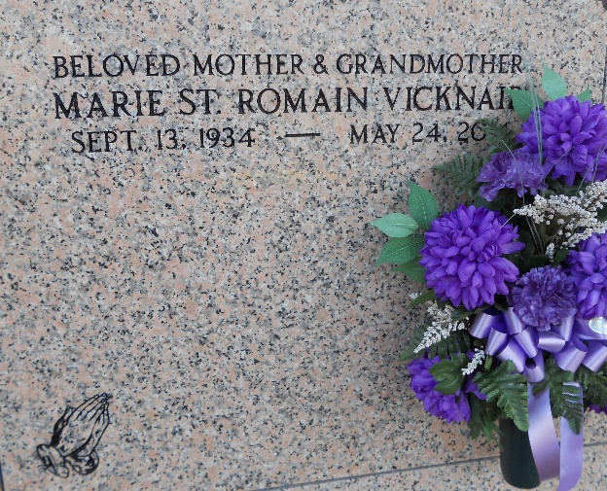
Photo by Team T-Lo

Marie St. Romain Vicknair Morgan died on May 24, 2014.
Beloved wife, by first marriage, of the late Francis Vicknair and former wife of the late Jim Morgan. Mother of Mary Powell (Gene), Janet Alexander (Robert), Todd Vicknair (Lisa), Penny Dufrene (Mike) and the late Francis Vicknair Jr. Grandmother of Gene and Tommy Powell, Vickie Greichgauer, Melissa Alexander Roussel, Jennie Alexander, Todd, Justin and Kayla Vicknair, Cameron Phillips and the late Robin Alexander. Also 8 great-grandchildren.
Daughter of the late William and Viollette St. Romain. Sister Ethel Ringo and the late Sharkey, Robert, Adam and Ivy St. Romain, Lena Roubique, Inez Casey and Mary Braud. Age 79. A native of Rougon, LA and a resident of LaPlace, LA.
Relatives and friends are invited to attend services. Visitation at Ascension of Our Lord Catholic Church, 1900 Greenwood, LaPlace, LA from 9:00am to 11:00am on Wednesday May 28, 2014, followed by Mass at 11:00am. Burial in St. Peter Cemetery, Reserve, LA.
Special thanks to the Doctors, Nurses and Staff of The Crossing, at Clarity Hospice of Baton Rouge for their excellent care and kindness provided during the last week.
Arrangements by Millet-Guidry Funeral Home, Laplace, LA.

The New Orleans Advocate, Louisiana
May 25 to May 28, 2014

