Marie Virginia (Clement) Vicknair
May 5, 1890 – October 26, 1957

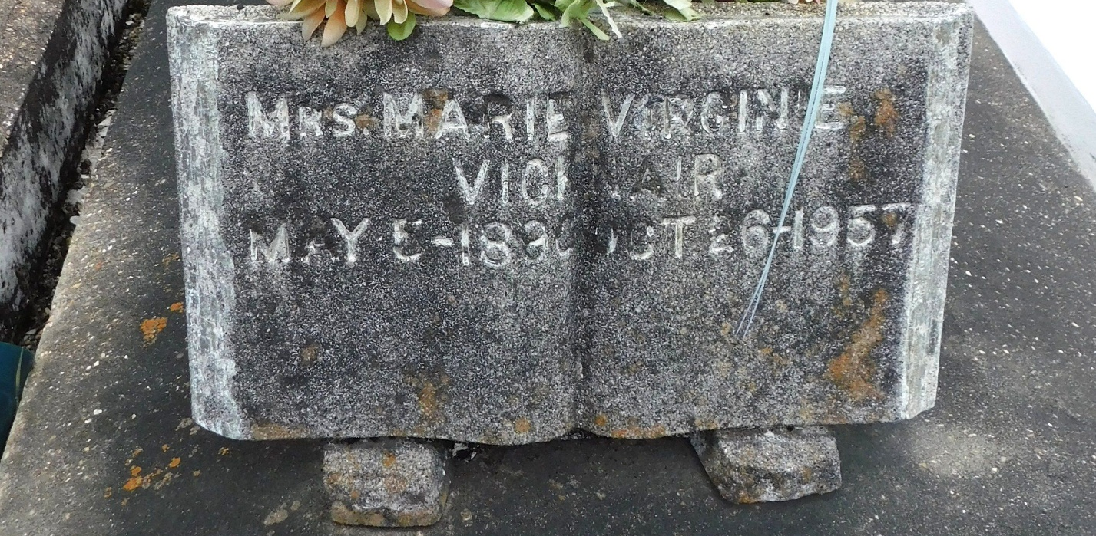
Photo by Mary Agnes Hammett

VICKNAIR-At the residence, Montz, La, on Saturday, Oct 26, 1957, at 8:45 o'clock p.m., MARIE VIRGINIA CLEMENT, beloved wife of Paul Vicknair, mother of Mrs. Earlis Madere, Mrs. Eddie Jouty, Mrs. Henry Ancale, Mrs. Jules Hymel, Jeffery, Delaune, Ambrose and Henry Vicknair; also survived by 13 grandchildren and three great grandchildren, age 67 years, native of Laplace, La, and a resident of Montz, La, for the past 50 years.

Relatives and friends of the family are invited to attend the funeral which will take place from Millet funeral home, Laplace, La, on Monday, Oct 28, 1957 at 9 o'clock a.m., followed by Mass at St. Joan of Arc church, Laplace, La. Interment in St. Peter cemetery, Reserve, La.
The Times-Picayune, New Orleans, Louisiana
October 28, 1957, p. 3

