Mary Anna (Duhe) Vicknair
September20, 1933 – June 22, 2016

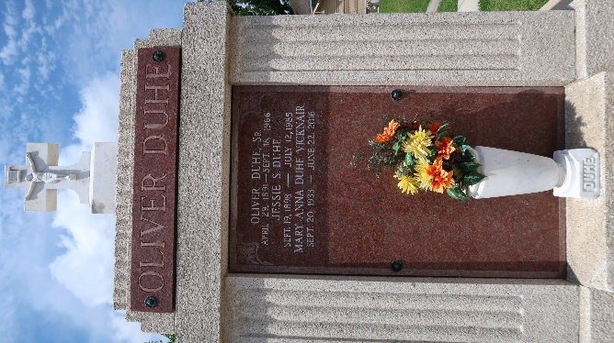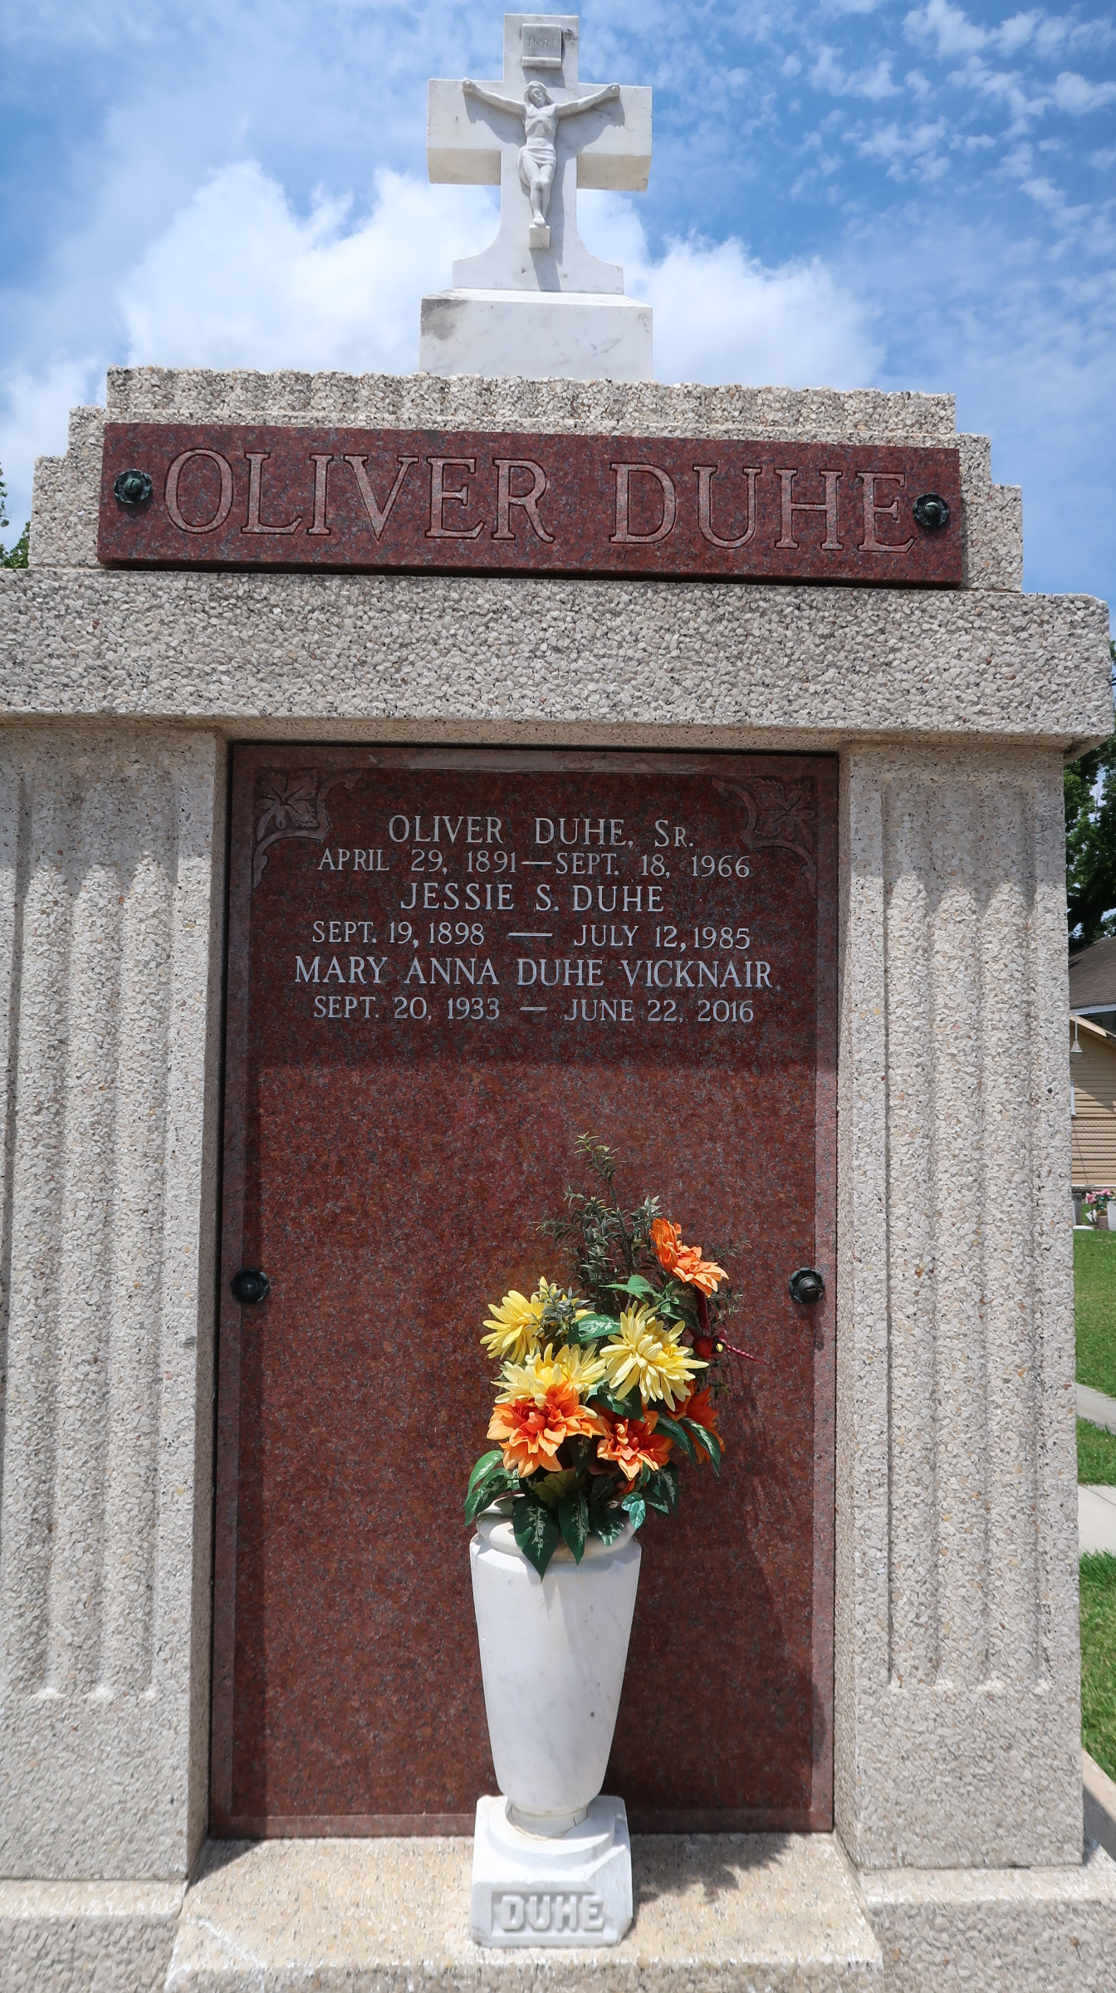

Mary Anna Duhe Vicknair passed away on Wednesday, June 22, 2016 in LaPlace. She was 82, a native of New Orleans and a resident of Reserve.

Beloved wife of the late Nelson Vicknair. Mother of Michael, Scott and Jarret Vicknair. Grandmother of Makala and Mason Vicknair, Dominick Vicknair and Dillon Vicknair. Daughter of the late Jessie Sutton Duhe and Oliver Duhe. Sister of the late Oliver Duhe, Sylvester Duhe and Lionel Duhe.

Relatives and friends are invited to attend the Funeral Mass at St. Peter Catholic Church, 1550 Hwy. 44, Reserve, on Saturday, June 25, 2016 at 10:00 a.m. Visitation at the church from 8:00 a.m. to 10:00 a.m. Interment in St. Peter Cemetery. Arrangements by Millet-Guidry Funeral Home.
The New Orleans Advocate, Louisiana
Jun. 23 to Jun. 25, 2016

