Michel J. Vicknair
September 25, 1909 – September 4, 1985

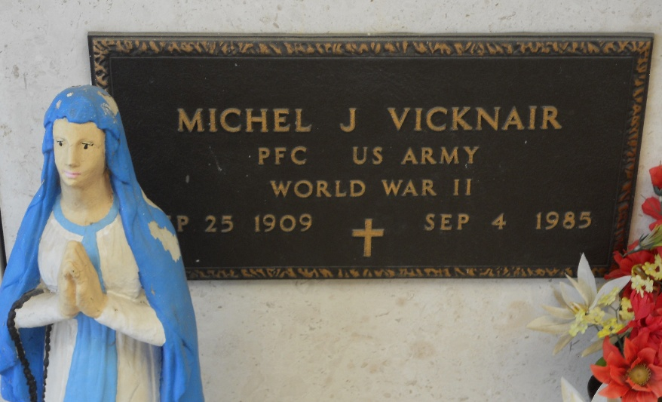
Photo by Team T-Lo

Funeral services were Sept 6 [1985] for Michel J. Vicknair, 75, a native and resident of Reserve. He died at 12:35 am Sept 4 [1985].

He is survived by his wife, Florence Montz Vicknair; three children, Mrs. Julius (Berdine) Granier of New Sarpy, Mrs. Florence Vicknair of Laplace and Mrs. Ray (Trudy Ann) Martin of Grand Point; and one sister and two brothers, Trezema (Noon) Vicknair of Reserve, Mrs. Dennis (Louise) Millet of Reserve and Fortune (Bab) Vicknair of Laplace. He is also survived by 5 grandchildren.

Religious services were at St Peter Catholic Church in Reserve with interment in the church cemetery.

L’Observateur, LaPlace, Louisiana
Unknown date

