Mollie Thersa (Hebert) Vicknair
July 20, 1937 – September 8, 2000

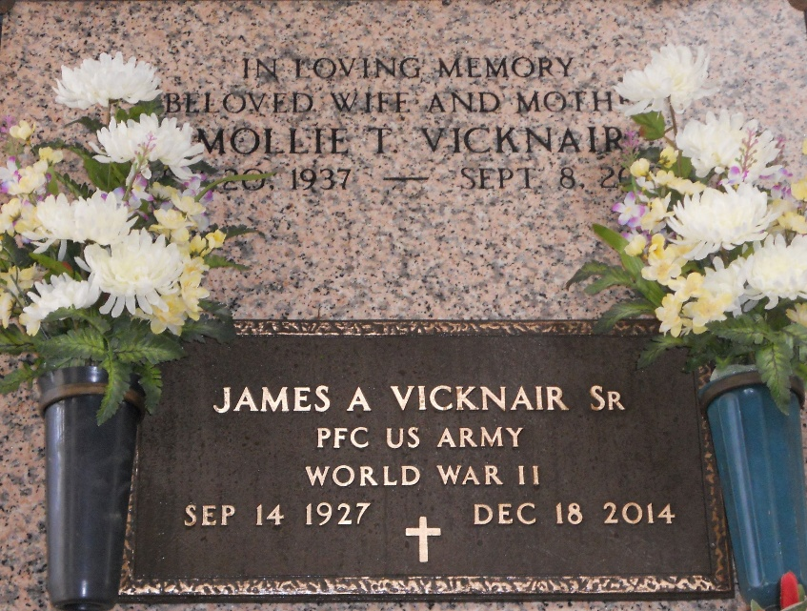
Photo by Team T-Lo

Mollie Hebert Vicknair, 63, a native of New Orleans and resident of LaPlace for 63 years, died Sept. 8.
She was the wife of James A. “Tim” Vicknair Sr. and mother of seven. She was also the daughter of Rubie Tabb Hebert and the late August Hebert and sister of Gloria Massi, Odile Bruno, Thelma Durham and Vincent, August and Felix Hebert. She is also survived by 15 grandchildren.
Services were Sept. 11 in the chapel of Millet-Guidry Funeral Home, LaPlace, with interment at St. Peter Cemetery, Reserve.
L’Observateur, LaPlace, Louisiana
September 13, 2000

