Nemea (Ory) Vicknair
February 17, 1879 – April 18, 1969

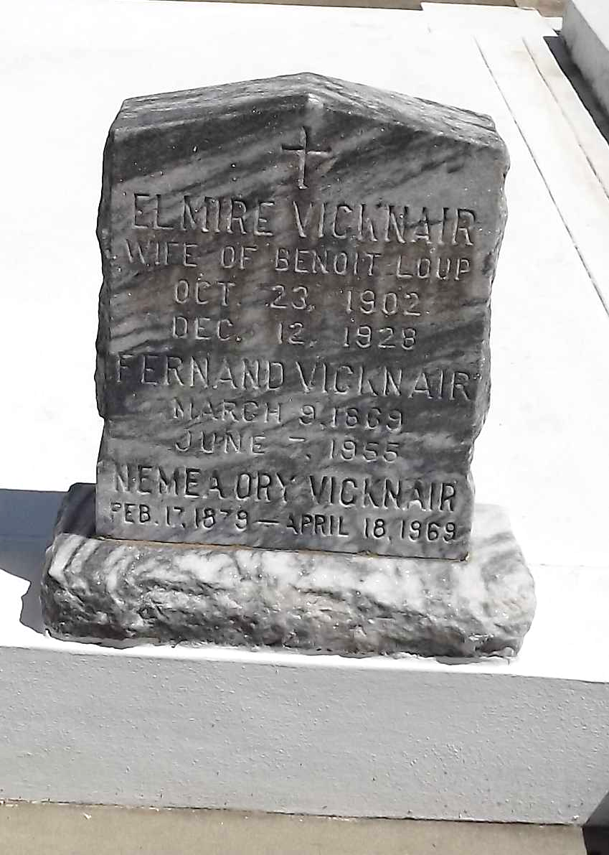
Photo by Mary Agnes Hammett

Wife of the late Fernand Vicknair and daughter of the late Theodule Ory and Elizabeth Tregre. Mother of Nolan Vicknair of Mt Airy, Louisiana, Eddie Vicknair of Gramercy, LA, Lester Vicknair and Mrs. Clarence Geier St of Metairie, LA, Mrs. Guy T. Landry of Gretna, LA, and the late Freddie Vicknair and Mrs. Elmire Loup. Sister of Abel Ory, Mrs. Warren Jackson, and the late Lionel and Marcelin Ory, Mrs. Elvire Lambert and Mrs. Sidonie Lohman.

Services were Saturday 19 Apr 1969 at St Hubert Church, Garyville, LA, with interment in St Peter Cemetery, Reserve, LA.
The Times-Picayune, New Orleans, Louisiana
April 19, 1969

