Norris Peter Vicknair
March 27, 1933 – June 11, 2006

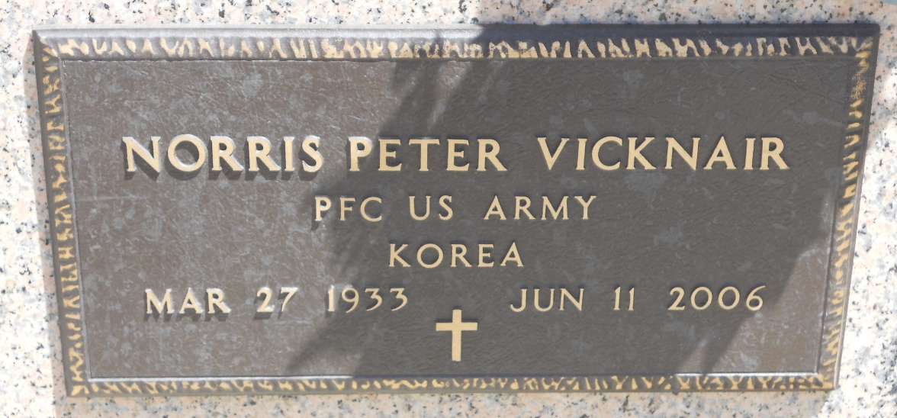
Photo by Team T-Lo

Norris P. Vicknair on Sunday June 11, 2006 at 9:00 p.m.

Beloved husband of Natalie (Nat) Tregre Vicknair. Father and Father-in-law of Chad and Rebecca Vicknair and Cobi and Lane Harrington. Also survived by 9 grandchildren.

Son of the late Benoit and Adolphine Vicknair. Brother of the late Everett Vicknair. Also survived by nieces and nephews. He was an Army Veteran. Age 73, a native and resident of Reserve, LA.

Graveside Services were held at St. Peter Cemetery, Reserve, LA on Monday, June 12, 2006. Arrangements by Millett-Guidry Funeral Home, Laplace, LA.

The Times-Picayune, New Orleans, Louisiana
June 13, 2006

