Octave Vicknair
August 24, 1843 – June 18, 1913

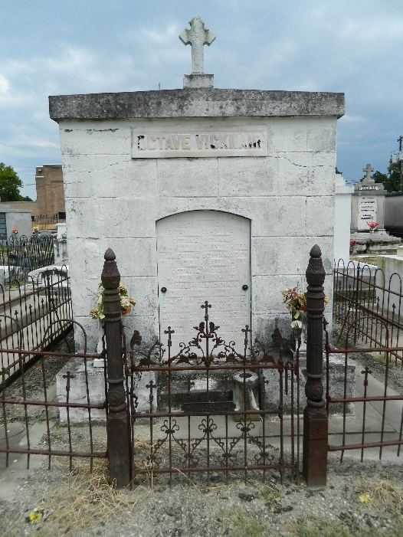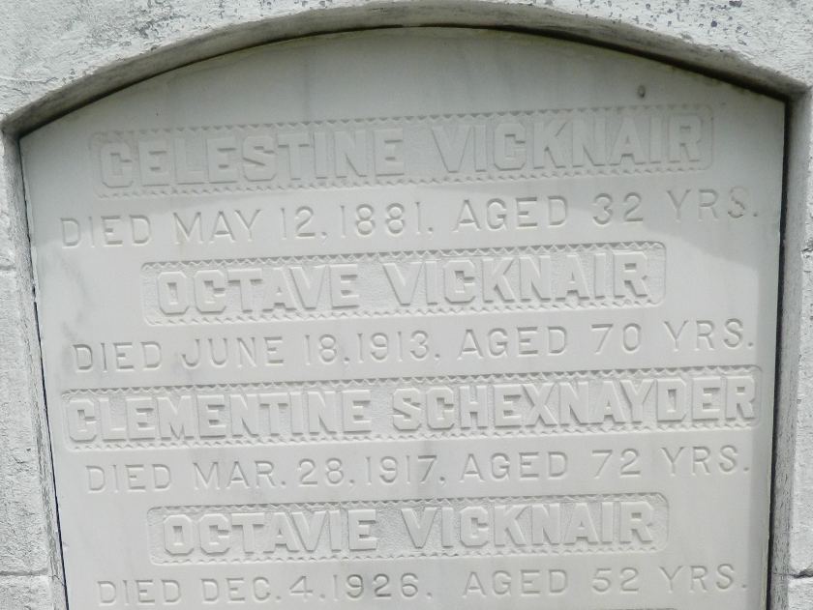

On Wednesday, the 18th of June, at nine o'clock in the evening, Mr. Octave Vicknair, aged 69 years and 10 months, died at Touro Infirmary in New Orleans following an accident Monday morning while caring for his livestock.

Mr. Vicknair was a resident of Mount Airy in the 6th Ward. In 1896, he was elected a member of the police jury but he immediately resigned the position declaring that if he could not represent those who had put him in place rather than being dictated by personal interests he preferred to resign.

His funeral was yesterday, Friday, at four o'clock in the evening at St. Peter's Church amidst a considerable influx of relatives and friends.

L'Observateur, LaPlace, Louisiana
21 Jun 1913, p 1 (in French)

