Odile (Klibert) Vicknair
December 1, 1908 – May 9, 1976

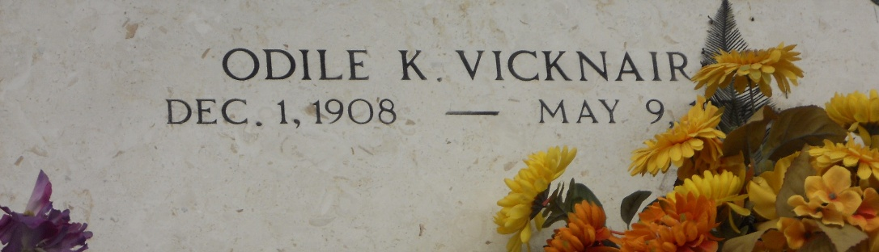
Photo by Team T-Lo

Odile Klibert Vicknair, on Sunday, May 9, 1976 at 10:30 p.m., beloved wife of Edgar J. Vicknair Sr. of Reserve, mother of Mrs. Sidney (Dorcey) Hotard, of Convent, La, Mrs. Ernest (Mary Lee) Ragsdale of McDonald, Tennessee, Edgar Jr, of Reserve, La, and Curtis Vicknair of Mount Airy, La, foster mother of John Gary Barre, age 67 years, a native of Vacherie, La. and a resident of Reserve for the past 56 years.

Relatives and friends of the family, also members of the St Peters Ladies Altar Society are invited to attend the funeral services from Millet Funeral Home, Reserve, La. on Tuesday, May 11, 1976 at 1:30 p.m. Followed by religious services at St. Peters Catholic Church. Interment in Church Cemetery.

The Times-Picayune, New Orleans, Louisiana
11 May 1976, p. 12

