Olga Marie (Ory) Vicknair
January 1, 1900 – February 23, 1959

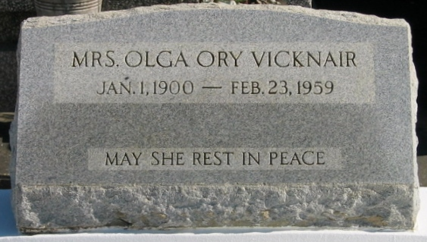
Photo by Bobby

Died at her late residence in Reserve, Louisiana, at age 59 years. Wife of Albert Vicknair and mother of Mrs. Margie Williams. Sister of Mrs. Emma Boudreaux of Reserve, Leo Ory and Mrs. Leo Simon of New Orleans and Joseph Ory of Biloxi, Mississippi.

Services were Wednesday, 25 Feb 1959, at St Peter Church, Reserve, with interment in St Peter Cemetery.

Unknown source

