Pauline (LaBranche) Vicknair
April 6, 1915 – July 6, 1973

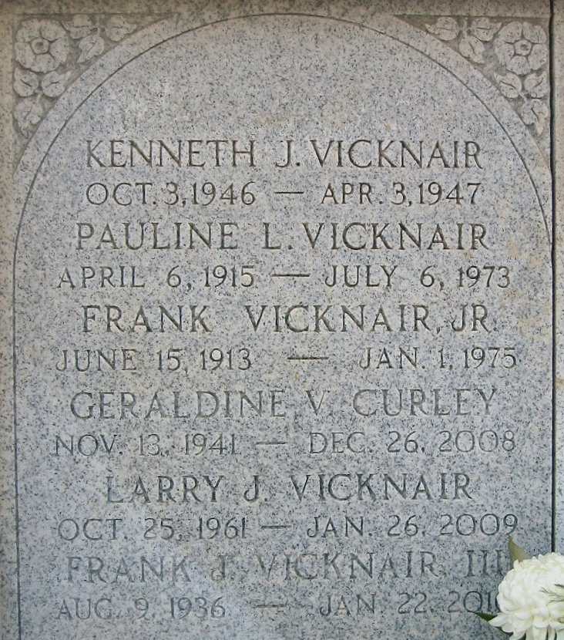
Photo by Bobby

Age 58 years, a native and resident of Laplace, Louisiana. Wife of Frank Vicknair Jr. Mother of Frank III, Floyd, Gerald, Geraldine and Gary Vicknair, all of Laplace, and Mrs. Lyle (Gladys) Elfer of Reserve.

Daughter of the late Mrs. and Mrs. Leopold LaBranche, sister of Joseph, Paul and Earl LaBranche, all of Laplace, Mrs. Alfred Schexnayder and Mrs. Ella Madere of Laplace, Mrs. Remy Granier of New Orleans and the late Henry LaBranche.

Services were Monday, 9 Jul 1973, at St. Joan of Arc Church, Laplace, with interment in St. Peter Cemetery, Reserve, Louisiana.
The Times-Picayune, New Orleans, Louisiana
9 July 1973

