Penny Marie (Oubre) Vicknair
February 19, 1940 – December 17, 2025

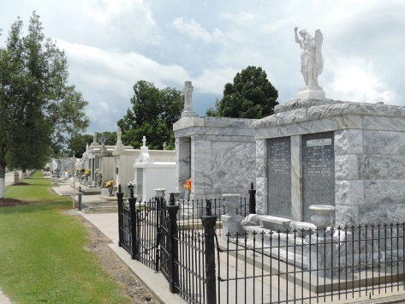

Penny Marie Oubre Vicknair, age 85, passed away peacefully on December 17, 2025, surrounded by love and family. Born on February 19, 1940, in Garyville, Penny dedicated her life to caring for others. She was a loving wife to her late husband, Bob, a proud mother of five children, a cherished grandmother to ten grandchildren, and a joyful great-grandmother to numerous great-grandchildren, each of whom held a special place in her heart.
For many years, Penny worked as a teacher at Riverside Academy, where her gentle guidance, steady encouragement, and nurturing spirit shaped countless young lives.
She was known for her comforting wisdom and the simple phrases that carried profound meaning. Two of her most beloved sayings, "hug your shoulders" and "follow the angels," will forever echo in the hearts of those who knew her, offering reassurance in moments of uncertainty and love in times of need.
Penny found joy in family gatherings, quiet moments of reflection, and watching her family grow through the generations. Her home was a place of welcome, where laughter was shared freely and love was unconditional.
She is survived by her children: Gay Duhon (Doug), Bobby Vicknair (Mandy), Lynne Kissinger (Gary), Clair Becnel (Shawn), and Julie Trosclair (Kyle), grandchildren: Doug Duhon, Jr, Mary Douglas, Heather Graugnard, Heidi Faul, Stacy Bryan, Dustin Weber, Gary Kissinger, Jr., Dylan Becnel, Jayce Becnel, Kameron Trosclair, Kylie Trosclair, many great-grandchildren, and many extended family members and friends who will miss her dearly. She was preceded in death by her husband Robert Vicknair, Sr, parents: Hubert Oubre, Sr, Clara Oubre, siblings: Coleman Oubre, Odile Ryan.
The family extends their sincere gratitude to the physicians, nurses, and medical staff at OLOL, especially Dr. Militello, Nurse Kim, and Dr. Setliff for their compassionate care and professional dedication.
Relatives and friends are invited to attend a Funeral Mass and Visitation on Tuesday, December 23, 2025, at St. Joseph Catholic Church, 2130 Rectory St, Paulina, LA 70763. Visitation will be held from 8:30 a.m. until 11:00a.m. The Funeral Mass will begin at 11:00 a.m., and interment will take place immediately after at St. Peter Catholic Cemetery in Reserve, LA.

Rose Lynn Funeral Home, Lutcher, Louisiana

