Pierre Octave Vicknair
August 1, 1898 – June 6, 1978

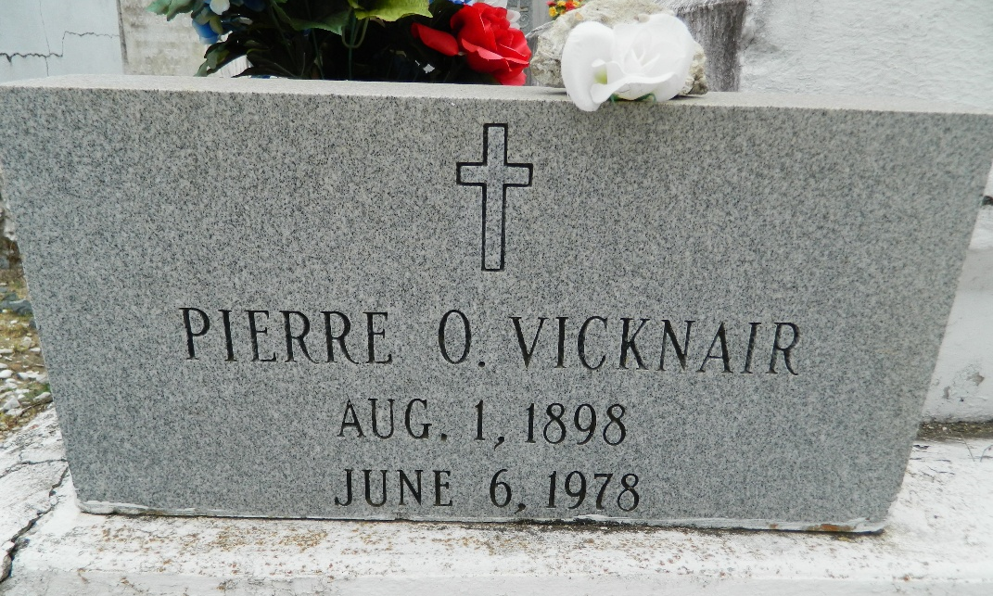

Pierre O. Vicknair, on Tuesday, June 6, 1978 at 2:00 am, beloved husband of the late Eleanor J. Vicknair, father of Corinne Weber, Mary Ellan Scioneaux and Harry Vicknair, all of Reserve, also Gladys Maurin, Peter and Donald Vicknair, all of Laplace, and the late Plymouth and Robert Vicknair, survived by 22 grandchildren and 15 great grandchildren, age 79, a native and resident of Reserve.

Relatives and friends of the family are invited to attend the funeral services from Millet Funeral Home, Reserve, LA, on Thursday, June 8, 1978 at 10:00 am. Followed by religious services at St Peter's Catholic Church. Interment in Church Cemetery.
The Times-Picayune, New Orleans, Louisiana
7 Jun 1978, p. 14

