Pierre Valzume Vicknair
November 5, 1874 – December 26, 1963

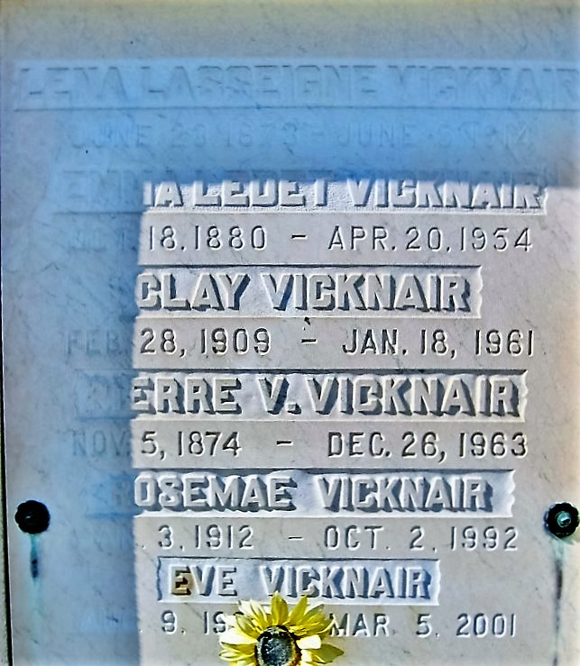
Photo by Bobby

Pierre V. Vicknair died Thursday, 26 Dec 1963, at age 89 years.

Husband by first marriage of late Lena Lasseigne and by second marriage of late Emma Ledet. Father of Eve, Rosema and the late Clay Vicknair. He was a native and resident of Reserve, LA.

Services were 27 Dec 1963 with interment in St Peter Cemetery, Reserve, LA.
The Times-Picayune, New Orleans, Louisiana
December 27, 1963

