Prosper L. Vicknair Jr.
July 23, 1937 – March 28, 2009

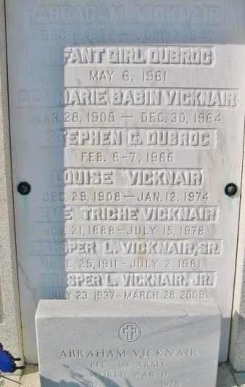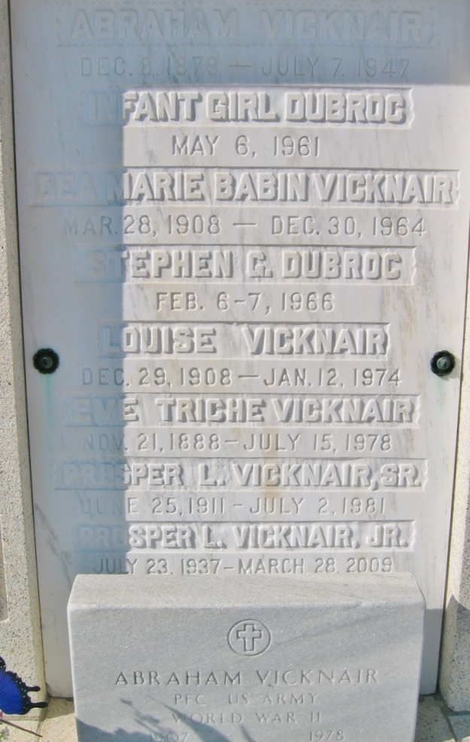
Photos by Bobby

Prosper L. (Juicy) Vicknair Jr. on Saturday, March 28, 2009 at 9:10 am.
Beloved wife (sic) of Connie Vicknair. Father of Alvin Vicknair & wife Brandy and Glen Vicknair & wife Melanie. Grandfather of Gavin, Grace and Emily Vicknair.
Son of the late Prosper and Dea Vicknair. Nephew of Julie Vicknair. Brother-in-law of Sherry Vicknair & Donald Vicknair and wife Glenda. Uncle of Mary Kay Vicknair and Julie Cox.
Special thanks to relatives, friends and loyal customers. Age 71. A native of Montz, La. and a resident of Garyville, La. for the past 5 yrs. He was a retired school bus driver for St. Charles Parish School Board. He was a lifetime vegetable farmer.
Relatives and friends are invited to attend Memorial Services. Visitation at St. Peter Catholic Church, Reserve, La. on Wednesday, April 1, 2009 from 8:30 am to 9:30 am. Followed by Religious Services at the church at 9:30 am. Burial in St. Peter Cemetery.
In lieu of flowers, donations preferred to St. Peter Catholic Church, Reserve, La. Arrangements by Millet-Guidry Funeral Home, LaPlace, La.
The Times-Picayune, New Orleans, Louisiana
March 31, 2009

