Rita Bruno (Vicknair) Vicknair
July 4, 1920 – May 29, 1979

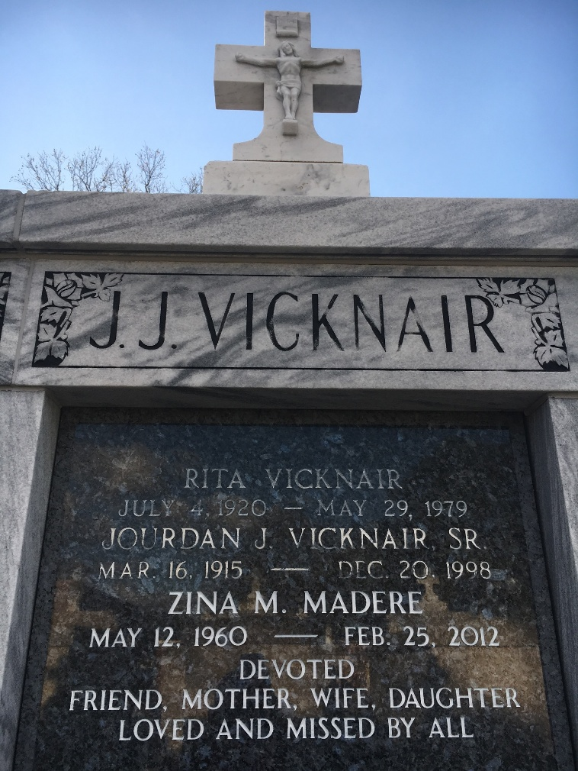
Photos by Team T-Lo

Rita Bruno Vicknair died Tuesday, 29 May 1979, at age 58 years.

Wife of Jourdan Vicknair and mother of J. J. and Wayne Vicknair, Barbara V. Millet, Elaine V. Cortez and Judy V. Mathvin.

She was a native of Reserve, LA, and a resident of Laplace, LA, for 46 years.

The Times-Picayune, New Orleans, Louisiana
30 May 1979

