Robert Lucien Vicknair Sr.
November 12, 1937 – January 13, 2023

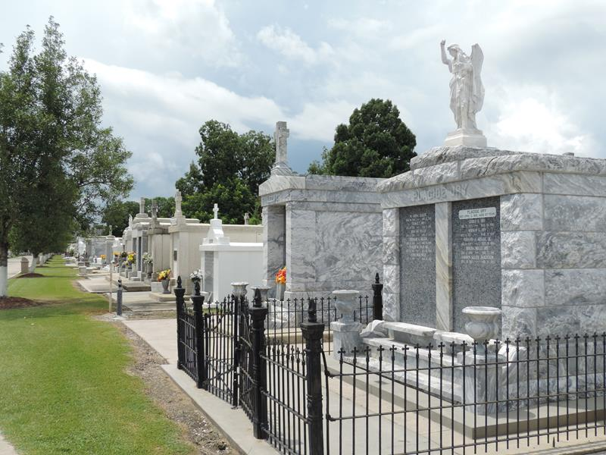

Robert (Bob) Lucien Vicknair, Sr. 85, born and raised in Reserve, Louisiana. He passed away peacefully at his home in Grand Point, Louisiana on Friday, January 13, 2023.
Bob is predeceased by his parents Mederic & Marie Vicknair, his sister Josephine Millet, brothers: Nelson, June, Rodney, & Wilson Vicknair.
Survived by his loving wife, Penny Oubre Vicknair, and 5 children: Gay (Doug) Duhon, Bobby (Mandy) Vicknair, Lynne (Gary) Kissinger, Clair (Shawn) Becnel, and Julie (Kyle) Trosclair as well as his sister, Ida Wilson, 10 grandchildren: Douglas Duhon Jr, Heather Graugnard, Heidi Faul, Mary Vicknair, Stacy Weber, Dustin Weber, Dylan Becnel, Jayce Becnel, Kameron Trosclair, and Kylie Trosclair and 13 great-grandchildren.
Bob was a proud veteran of the US Marine Corps. He retired in 1992 from Nalco Chemical.
He was an avid supporter of Riverside Academy. In his spare time, Bob could be found cheering on the LSU Tigers and Riverside Rebels. He was a proud member of the "Rusty Rebels". Bob enjoyed spending time with his family, hunting and fishing with his brothers and son and working in his yard.
Relatives and friends are invited to attend the Visitation and Funeral Mass at St. Joseph Catholic Church, 2130 Rectory St., Paulina, LA on Monday, January 16th, 2023. Visitation at the church from 9:00 a.m. to 11:00 a.m. followed by a Funeral Mass at 11:00 a.m. In lieu of flowers, the family requests donations be made in memory of Bob Vicknair to Riverside Academy 332 Railroad Ave, Reserve, LA.

Rose Lynn Funeral Home, Lutcher, Louisiana

