Robert Paul Vicknair, PFC
March 11, 1925 – July 8, 1944

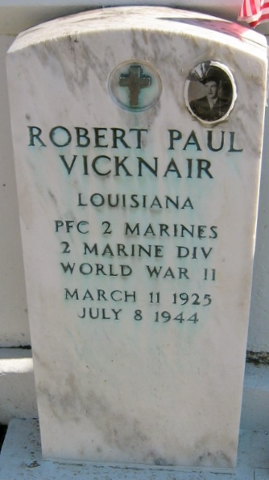
Photo by Bobby

VICKNAIR-In the service of his country on Saipan, on July 8, 1944. PFC ROBERT PAUL VICKNAIR; beloved son of Pierre Vicknair and Elanore Jacob; brother of Mrs. Eddie Weber, Mrs. Ernest Scioneaux, Clement, Harry, Gladys, Donald and Peter Vicknair; age 19 years.

Relatives and friends of the family, also officers and members of American Legion, Reserve Post 159, VFW Reserve Post No. 5004, are respectfully invited to attend the funeral which will take place from the Millet Funeral Home, Reserve, LA, on Friday, December 31, 1948, at 9 o'clock a.m. Religious services at St Peter's church, Reserve, LA, at 10 O'clock. Interment in St Peter's Cemetery.
The Times-Picayune, New Orleans, Louisiana
30 Dec 1948, p. 2

