Ronald J. Vicknair Jr.
October 5, 1953 – March 7, 2014

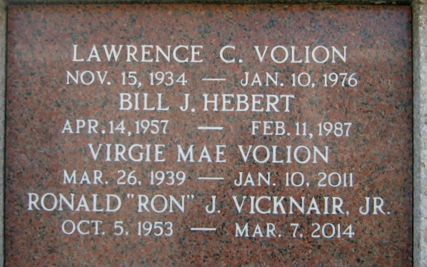
Photo by Bobby

Ronald J. Vicknair Jr., died on Friday, March 7, 2014.

Beloved husband of Jody Volion Vicknair. Father of Donna, Kody, Holly and Kelli Vicknair. Grandfather of Lawson Vicknair and Kyah Fobb.

Son of the late Ronald and Gloriajean Vicknair. Brother of Cheryl and Herbert St. Martin, Jeffrey, Loretta and Michael Vicknair, Lawrence and Dot Volion, Donna and David Maurin, Larry and Kim Townsend and the late Gary King. Also survived by nieces, nephews whom he loved like his own children. Age 60. A native and resident of Reserve, LA.

Relatives and friends are invited to attend services. Visitation at Millet-Guidry Funeral Home, 2806 W. Airline Hwy., LaPlace, LA on Tuesday March 11, 2014, from 8:00am to 10:00am, followed by Religious Services in the Funeral Home Chapel at 10:00am. Burial in St. Peter Cemetery, Reserve, LA.
The Times-Picayune, New Orleans, Louisiana
March 8-9, 2014

