Rose Vicknair
Abt. 1874 – December 16, 1974

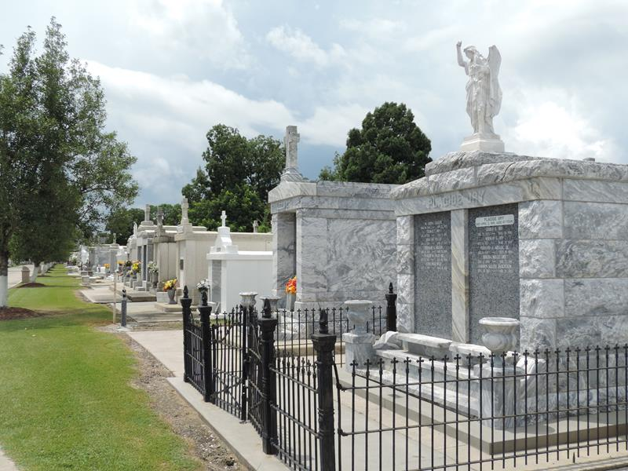

Rose Vicknair of Laplace, La. on Monday, December 16, 1974 at 11:10 o’clock a.m.
Mother of Ema? McGee Creecy, Marie G. Vicknair and Rozelia Wilson, all of Laplace, La. Also survived by 9 grandchildren, 14 great-grandchildren and 4 great-great grandchildren, a host of nieces, nephews and other relatives and friends.
Relatives and friends of the family, also parishioners of Our Lady of Grace Catholic Church of Reserve, La. and officers and members of Deinfiafiance Society of Reserve are invited to attend the funeral. Services from Robottam Mortuary on Thursday, December 19, 1974 at 10:00 o’clock a.m., followed by Requiem Mass at Our Lady of Grace Catholic Church. Interment in St. Peter Cemetery, Reserve, La.
Wake services at the above named mortuary on Wednesday night, December 18, 1974. Recitation of the Rosary at 8:00 o’clock p.m.
The Times-Picayune, New Orleans, Louisiana
Wednesday, December 18, 1974

