Sidney Daniel Vicknair
February 4, 1935 – October 30, 2024

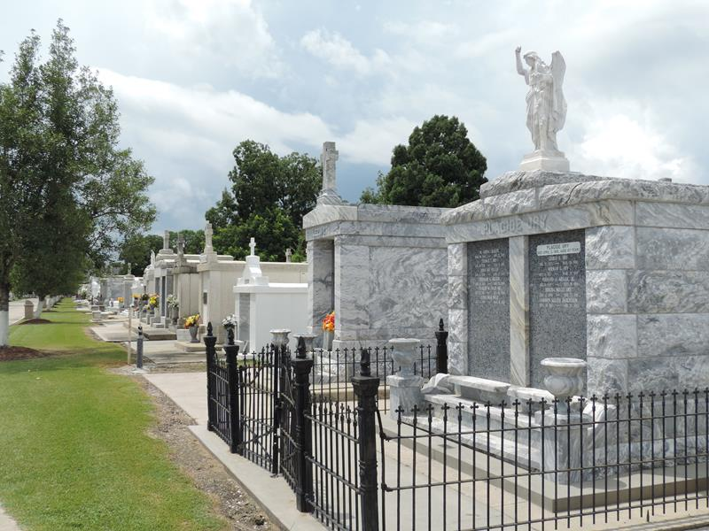

Sidney D. Vicknair, beloved husband of the late Geraldine Vicknair. Owner and operator of the well-known Snake Farm in LaPlace, passed away on Wednesday, October 30, 2024, at the age of 89.
Sidney proudly served his Country in the U.S Marines. Sidney was a devoted member of the LaPlace community, where his passion for animals and unique wildlife experiences brought countless visitors and joy to the area. Known for his dedication, knowledge, and the spirit of adventure, Sidney transformed Snake Farm into a cherished local attraction, sparking curiosity and respect for reptiles and exotic animals. Sidney’s family, friends, and community will remember his warmth, kindness, and enthusiasm.
Sidney is survived by his children Lawerence Vicknair, Sandra Vicknair, Glen Vicknair and Johnny Vicknair. Grandfather to eight grandchildren and twelve great grandchildren.
Relatives and friends are invited to attend the Visitation and Prayer Service at Millet Funeral Home, 2806 W. Airline Hwy, LaPlace on Friday, November 8, 2024. Visitation will be held from 1:00 p.m. to 3:00 p.m. followed by Prayer Service at 3:00 p.m.

Millet – Guidry Funeral Home, LaPlace, Louisiana

